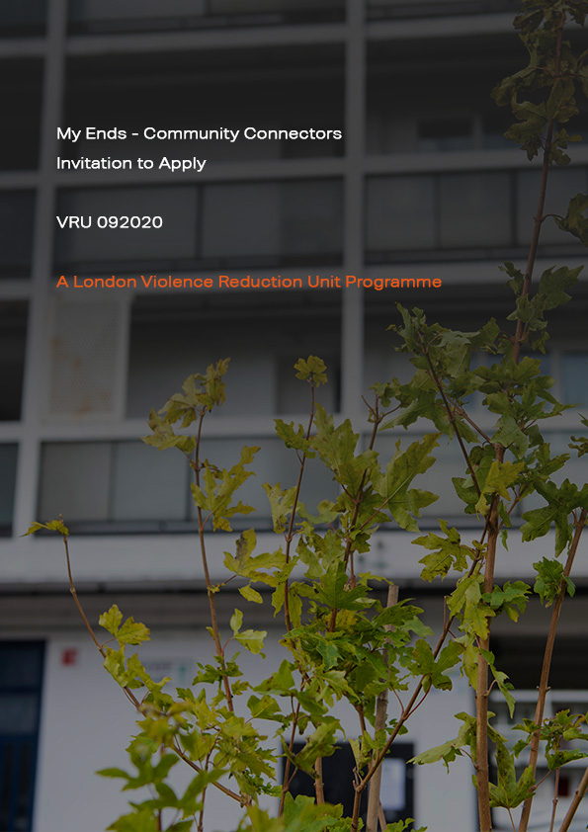

Foreword

MyEnds

It’s where your friends live, and where you spend your days, it’s where you hang out, it’s where you were raised. It’s the backstreets and shortcuts you know better than any map app, and the familiar faces you see when you pop to the shops. It’s family, it’s familiar, it’s the places where you should feel safe. It’s those spots that are tied to those moments that your memory can never erase. It’s your ends – and whilst it might not always feel like where you truly belong, at the end of the day it’s still where you’re from.

In some parts of London, we know that violence is very localised. It is often concentrated in areas as small as an estate or a cluster of streets.

We also know that the energy and effort to tackle violence is often held by those communities that are most affected by it.

Our new MyEnds programme seeks to channel that energy and effort into community-led solutions.

But to make an impact we need strong, local, collaborative work. Violence doesn’t respect borough boundaries. Therefore, we need an equally ambitious response from communities that also pushes boundaries, breaks down barriers, and promotes partnerships. Put simply we are stronger if we work together.

We’re inviting applications for the MyEnds programme because we want to develop new sustainable, effective, community-led responses to violence.

About this form

This form should be used to submit your proposal for the MyEnds - Community Connectors funding opportunity (referred to as MyEnds herein). You must answer all the questions in this form.

Sending us your form

Email a copy of your Application Form to vrucommissioning@london.gov.uk.

Deadline

Your form must reach us before 5pm on 23rd October 2020. We will not accept proposals after this deadline.

Table of Contents

PART A: INFORMATION 5
- About London’s Violence Reduction Unit 5
- About the programme 6

PART B: APPLICATION FORM 12
- Guidance 12
- Specification 14
  - Cover page 14
  - Essential criteria 16
  - Key criteria 19
  - Costs and funding 27
  - Checklist 29

PART C: APPENDICES 30
- Appendix A - Timeframes 30
- Appendix B - Theory of Change 32
- Appendix C - Data sources 33

PART A: INFORMATION

About London’s Violence Reduction Unit

Keeping Londoners safe is the Mayor of London’s top priority. The London VRU was set up by the Mayor in the autumn of 2018 as the first VRU in England and Wales. We are tasked with reducing and stabilising violence across the capital, increasing feelings of safety for all Londoners, and ensuring that communities and young Londoners are at the heart of sustainable and long-term change.

We have drawn on lessons from the successful Glaswegian model and are taking our own London-specific public health approach to tackling violence. We are bringing together specialists from health, police, local government, schools, probation, and community organisations to tackle violence and its underlying causes, and to promote positive opportunities particularly for vulnerable young Londoners.

Our work is overseen by our Partnership Reference Group (PRG) which is chaired by the Mayor himself and comprises leading figures in the public sector alongside representatives from voluntary, community, and youth groups. The PRG provides strategic direction, support, and challenge to the Unit to ensure that we stay directly accountable to the communities we were set up to serve.

In September 2019, we published our strategy and work programme containing three strategic aims:

- To reduce and stabilise violence across London – violence is a concern for us all; we will all play our part to reduce it.
- To increase feelings of safety – recognising that London is one of the safest cities in the world.
- To put community at the heart of our work – only by doing so do we have a sustainable long-term approach towards reducing violence. (Ref: VRU Strategy).

COVID-19 has had a significant and unprecedented impact on London and London’s communities. However, the VRU is reaffirming its commitment to supporting local communities and grassroots organisations to ensure that local networks and services survive post-lockdown, and to ensure that young people and families are able to access support in their localities in the years ahead.

About the programme

Introduction

The VRU has developed the MyEnds programme, allocating a total of £3.3 million (including an evaluation piece) to provide support, capacity, and funding for locally-designed interventions in neighbourhoods affected by high and sustained levels of violence.

The VRU expects that this work be grounded on a commitment to increase trust and collaboration between local communities, stakeholders, key local institutions, and statutory partners.

Equally, MyEnds is about increasing the sustainability of community networks, so that they are well placed to respond to local emerging needs and add long-term capacity and support to an area. As such, we are seeking consortium applications that demonstrate an ability to establish a local network which draws on the expertise of residents and stakeholders.

Developing this local network is an integral part of the programme – ensuring they are equipped with the skills, knowledge, and access to resources and information in order that they may help shape plans and ideas. By developing this ground-up approach, we hope to see the emergence of new ideas and locally-led interventions that reach those who need them most.

We are particularly keen to see applications that have the potential to produce:

- A strong consortium that has the skills, influence, passion, and the access to networks within the community in order to drive change there.

- Community networks that are empowered and strengthened, with these networks being composed of individuals who are closest to the issues and thus able to play a central role in leading the solutions.

- Creative, innovative, and effective local neighbourhood responses to reducing violence. We know that not everything will work, but we want to encourage challenging and creative mindsets nonetheless.

- Local communities that are aware of local initiatives and back them, who know how they can get involved, and are motivated enough to play their part.

To help shape this approach we have developed a high-level Theory of Change. A Theory of Change is a useful tool for communicating what your programme does and what impact it will make. It can also help identify which outcomes are key to your programme’s success and indicate which ones should be the focus of your evaluation efforts. Our Theory of Change is attached in Appendix B.

We have, through our Theory of Change, identified three strategic outcomes, set out below. However, each place is unique, and we will work with you to develop additional specific outcomes for your programme based on the needs of your local neighbourhood area and the interventions that are to be designed and delivered.

Strategic outcomes

- Stronger community networks that have a shared commitment to, understanding of, and vision for reducing violence.

- More inclusive decision-making between local stakeholders, statutory agencies, and communities, who are connected together and are collectively leading programmes that are reducing violence.

- Greater capacity within community-led networks. Networks are better equipped to monitor and adapt to emerging needs and, through them, people know that help is available, how to access it, and it is appropriate.

Describing your neighbourhood

A public health approach means no more looking at violence as an isolated incident. It doesn’t mean excusing criminality, but it does mean acknowledging that to genuinely change behaviour we need to look at the context and influences that impact on individuals at significant points in their life. It means understanding that no individual operates in a vacuum, but that they are both part of and influenced by a huge range of other contexts.

The VRU’s strategy is rooted in a contextual safeguarding approach which focusses on:
- Children and Young People – reducing Adverse Childhood Experiences and building resilience.
- Families and Home – supporting and enabling them to nurture and protect young people.
- Peers and Friends – supporting young people to be the best they can individually and together.
- Community and Neighbourhoods – enabling and empowering communities to lead from within to build sustainable futures.

Therefore, when we think about the work we want to do in making communities safer, the vision is a more resilient ability to lead change in reducing the vulnerabilities associated to neighbourhood. This could be a combination of actions within a residential area, a school, or a high street, for example.

We want you to define your neighbourhood in a way that’s meaningful to those who live there. Some examples of a neighbourhood area include:

- Residential areas and housing estates
- Wards
- A school catchment area

Who is eligible?

We are seeking consortia bids (a minimum of three organisations) from VCS and community-led organisations.

To be eligible to receive these funds, you must:

- Be a registered charity, charitable incorporated organisation, or a social enterprise – this includes companies limited by guarantee and community interest companies.

- Have demonstrable capacity, experience, and expertise to lead a consortium programme that will incorporate a range of stakeholders and partners at strategic and operational levels.

- Be in sound financial health with a positive end of year position in the previous financial year.

- Be working with vulnerable young people at risk of being involved in serious violence or their parent(s) or carer(s).

- Based in London and working with Londoners.

Working with local statutory agencies and partners

To deliver the outcomes we have identified it will be important for the consortium to work closely with local public sector institutions. Local Authorities, for example, are responsible for delivering a range of frontline services to local people. They are responsible for shaping development and investing in town centres. They build new homes and provide housing services. They invest in green spaces and are responsible for the public realm. All these services have a very direct and immediate impact to the success of a contextual approach to violence reduction.

Each borough has a Community Safety Partnership (CSP) which brings together the local authority, police, probation, health, and London Fire Brigade, with a responsibility to reduce crime within their area.

The VRU has worked with each borough’s CSP to support the development of a local violence reduction action plan. These plans involve close working between all of the organisations and it is important that your proposal takes a similar collaborative approach to work with these organisations – as well as communities and voluntary groups – to reduce violence.

Delivery elements

The consortium will be asked to undertake the following work and activities.

Programme mobilisation:

- Work with the VRU and local networks within the neighbourhood area to co-design your local delivery plan. Recognising every area is different, we can support consortiums in developing and identifying specific outcomes which address the local drivers of violence.

- Spend the appropriate amount of time setting up the programme, meeting with key stakeholders, and establishing the infrastructure to facilitate the programme. This includes establishing a broader local network who will collectively contribute to the delivery of the programme.

- Produce a community engagement and involvement strategy that reaches the widest parts of the local community and which amplifies the voice of young people who are all too often left out of the conversation.

- As part of the mobilisation process the VRU will work with consortiums to ensure that an Equality Impact Assessment (EIA) is undertaken, and that suitable monitoring is in place.

Interventions:

An important element of MyEnds is to develop and test new interventions that are appropriate to the needs of the local area. We believe that community-led interventions can generate new ways of doing things and we want to encourage and support this ethos.

We have identified four principles and approaches which are particularly relevant to a contextual approach to reducing violence. Please consider the below four principles and approaches when describing the intervention work you would like to develop in your application.

- The whole family approach. There is considerable evidence that supporting the whole family approach should be part of a holistic approach to reducing violence. The VRU has committed to developing resilient families who know how to identify issues of concern and know where to access information, advice, and guidance.

- Trauma-informed learning and practice. The consortium must be committed to developing and embedding an intersectional understanding of the impact of trauma and its effect on communities that have experienced violence.

- Peer-to-peer approaches. Where approaches focus on enhancing individuals’ capabilities to provide advice, information and support and to organise activities around health and wellbeing in their own or other communities. These approaches build on the skills, knowledge and commitment of individuals and then develop their capacity to become ‘agents of change’. The premise is that people will use their life experience, cultural awareness, and social connections to relate with other community members. They will be able to communicate in a way that people understand and reach those not in touch with services or not engaged by professional messages. Social support provided can be emotional (providing empathy and care), instrumental (helping with practical tasks), informational (providing advice), and appraisive (offering feedback and reflection).

- Cultural competence. London is one of the most ethnically diverse cities in the world and, as such, the expectation is for consortiums to work hard to understand their personal and organisational power and privilege, and the blind spots this may have created regarding the experience of these diverse communities. The upholding of inequality, however unintentional, will be embedded in unexamined structures, policies, and practice. The consortium will need to define and adopt a consistent set of behaviours, attitudes, and policies that come together across individuals, partnerships, interventions, and services. These should work effectively in cross-cultural situations and serve the differences and similarities across protected characteristics.

Budget and timeframes

We intend to make the MyEnds application process as accessible as we can. The application process contains two stages:

- Written submission and a video submission.
- Site visit and interview.

The programme will operate until 31 March 2023 where a minimum of four funded consortiums across London will benefit from a budget of up to £750,000 in total to design and deliver a place-based approach to reducing violence.

The second stage face-to-face interviews and visits will give applicants an opportunity to show the VRU what is happening on the ground so that we may understand how you are working locally and meet your broader networks.

An outline of the timeframes is set out in Appendix A.

Support from the VRU

We are a small team of specialists with a range of professional experiences gained from working in public health, London’s councils, the Metropolitan Police, the third sector, and as frontline youth workers. Many of our team also have lived experiences of growing up in areas that are disproportionately affected by violence.

Our range of experience within the team is available to you, including policy, research, advocacy, and general public sector knowledge and experience. The strength of this programme lies in how we will co-produce plans with you and support you along the way.

External evaluation of the programme

The VRU will commission and engage an evaluation partner(s) to work with the successful consortiums across the duration of the programme towards three main evaluation aims:

- Examine the nature and quality of the MyEnds programme, reviewing key lessons, strengths and barriers - including the programme overall and area-specific learning.
- Examine the impact produced by the programme, both intended and unintended with a focus on how the networks have developed (towards the end of the funding schedule).
- Capacity building the networks – the evaluation partner will work closely with networks to enhance their own insight and evaluation skills, processes and resources. This will include supporting the establishment of systems that aid continual learning and supporting networks to improve their data capture and monitoring capabilities.

Governance

The governance arrangements for this programme is outlined below:

- The VRU’s Head of Strategy and Partnerships will be responsible for grant management and monitoring to ensure effective delivery and value for money.
- The delivery partner(s) will be expected to report directly to the Assistant Director of the VRU, as and when requested.
- This programme will be subject to standard VRU programme monitoring approaches including quarterly reporting and monitoring visits.

PART B: APPLICATION FORM

Guidance
Please read and follow the guidance below on how to complete the specification.

STEP 1: Complete the specification
Award of the grant will be subject to a competitive process and evaluated by a panel against the requirements outlined in this Invitation to Apply. Bidders need to complete, in full. The specification contains the following sections:
- Cover page
- Essential criteria
- Key criteria
- Costs and funding
- Checklist

- Cover page: Please complete the cover sheet and provide a signature to confirm the information and costs provided are accurate.
Scoring standards | Criteria | Score
Outstanding | Fully meets the requirement and offers added value – The evidence demonstrates that the requirement is fully met and provides demonstrable added value. | 5
Good | Fully meets the requirement – The evidence demonstrates that the requirement is fully met. | 4
Satisfactory | Almost meets the requirement – Evidence provided shows that the requirement is met but MINOR reservations exist about the quality or extent of the evidence provided. | 3
Poor | Partially meets the requirements – Evidence provided shows that the requirement is partially met but SIGNIFICANT reservations exist about the quality or extent of the evidence provided. | 2
Unacceptable | Fails to meet the requirements – Failed to demonstrate or provide evidence of an ability to meet the requirement | 1
Non-compliant | Fails to provide the required information. | 0

- Essential criteria: All of these requirements must be clearly met and evidenced. If the bid fails any of these criteria the bid will not progress to the evaluation panel and will not be considered further. You must confirm (Yes or No) that you meet the requirements and if necessary, provide a written response.

- Key criteria: If the bid meets the essential requirements, then the bids will then be assessed against the following key criteria (below) and the qualitative evaluation weighting will be as follows:

Consortium eligibility | 45%
Neighbourhood needs profile | 30%
Ambition | 25%
TOTAL | 100%

Each evaluation requirement will be scored on a scale from: 0 = Non-compliant, to 5 = Outstanding.
If the overall combined scores for any section is below an average of three, then the overall bid will fail and will not be considered any further.

4. Costs and Funding: You must complete this form detailing costs of the programme.

5. Checklist: You must complete the Checklist to ensure all required documents have been completed.

Format and questions

- Font should be size 12 Arial;
- Strictly limited to page count outlined under each criterion;
- Additional diagrams, charts must be clearly labelled;
- Copies of requested policies and documents are excluded from the word count.
- Clarification questions should be emailed to VRU@london.gov.uk. All communications should, in the first instance, be sent to VRU@london.gov.uk.

STEP 2: Submitting your application
Once completed, you should email your application to the following email address: VRUCommissioning@london.gov.uk.

STEP 3: Application assessment
Please see Appendix A: Timescales for the full details on the assessment process.

STEP 4: Grant awarded and notice to unsuccessful providers
Please see the timetable for expected dates of notification. All bidders will be emailed directly to inform them of the outcome of the bid.

Specification

Deadline - your form must reach us at VRUcommissioning@london.gov.uk before 5pm on 23rd October 2020. We will not accept proposals after this deadline.

Cover page

MyEnds – Community Connectors Programme

Organisation name of lead provider
Name*
Position within the organisation
Address
Telephone number
Alternative telephone number

Email
Alternative email
Date

Signature*

*To be signed by Organisation Director or equivalent
I certify that the information provided is accurate to the best of my knowledge and that I accept the conditions and undertakings requested in the Invitation to Apply (ITA). I understand and accept that false information could result in rejection of the organisation’s apply.
I also understand that it is a criminal offence, punishable by imprisonment to give or offer any gifts or consideration whatsoever as an inducement or reward to any servant of a Public Body. I also understand that any such action will lead MOPAC to cancel any contract currently in force and will result in rejection of the Company’s application to apply and the cancellation of any contract (if awarded).
Legal name and contact details of consortium members:

Partner 1 – Main contact
Organisation
Full name
Position in organisation
Postal address including postcode
Email
Telephone number
Mobile telephone number

Partner 2 – Main contact
Organisation
Full name
Position in organisation
Postal address
Email
Telephone number
Mobile telephone number

Partner 3 – Main contact
Organisation
Full name
Position in organisation
Postal address
Email
Telephone
Mobile telephone number

Add additional boxes if necessary.

Specification

Essential Criteria

Ref | Essential Criteria | Confirm you meet the criteria  Response – no more than 300 words for each point where relevant or reference attachments
 |  | Yes / No
1 | Reference: Provide a minimum of two references. These should be references with contact details should there be further questions.
2 | Accounts: Provide two years of audited accounts.
3 | Structure Chart and Confirmation of lead: All bidders must provide a structure diagram, details of the key roles, responsibilities and reporting lines.
4 | Safeguarding: All bidders must provide assurance that front line staff have been DBS checked or provision of appropriate policy and processes to ensure oversight and safeguarding are considered when working with young people. All bidders should provide copies of their safeguarding policies and risk management processes. Bidders should also show evidence of safeguarding training.
5 | Equal Opportunities: All bidders must demonstrate commitment to equal opportunities and understanding of equality issues. All providers and services must be compliant with the public-sector equality duty set out in section 149(1) of the Equality Act 2010. This requires MOPAC (and its providers and services) to have due regard to the need to eliminate discrimination, advance equality of opportunity and foster good relations by reference to people with protected characteristics.  Equal opportunities policies must be provided. If the bid is from a consortium, these must be provided from all agencies involved.
6 | Sub-contracting: All bidders must provide details of any services that may be sub-contracted to a 3rd party during the contract period and must give details of those sub-contractors (including known consortium providers).
7 | Insurance:  All bidders must have adequate insurance cover (including but not limited to public liability insurance) with regard to liabilities and losses that may arise in connection with the Funded Activities and shall provide evidence of such insurance.  Professional Indemnity - £1M  Employers Liability - £10M  Public/Products Liability - £10M
8 | Health and Safety:  Health and Safety (H&S) regulations stipulate if a company has 5 or more employees it is obliged to have a H&S policy. Please confirm the following for all providers:  That your organisation has a written Health and Safety at Work Policy?  Please confirm your organisation complies with the Health and Safety at Work Act 1974?  Your organisation trains its staff in Health and Safety?  Please provide a copy of your H&S policy.
9 | Health and Safety continued:  Under the Reporting of Injuries, Diseases and Dangerous Occurrences Regulations (1995) (RIDDOR), how many reportable incidents and dangerous occurrences (near misses) has your company had?  For each occurrence please define:  - the date(s) when the incident occurred;  - what the incident involved;  - how the incident was recorded and  - what actions have been taken since the occurrence to mitigate future risk.

Specification

Key criteria

Ref | About your consortium  We are seeking consortium bids from VCS or community-led organisations who will work together within a defined geographical area in London. | Maximum score
1 | Please outline your expertise and experience in leading local violence reduction initiatives.  Notes:  When considering your experience please consider our public health approach to reducing violence and that this may cover experience which is linked to reducing a range of adverse childhood experiences and/or community environments or factors, such as not being in education or living in a high violence area. | 5
Enter response here (500 words)
2 | Please outline experience and expertise in leading a consortium programme that involves a range of stakeholders and partners at strategic and operational levels. | 5
Enter response here (500 words)
3 | Please describe how local statutory agencies such as the local authority, NHS and health services and the police will support your proposal.  Notes:  We are seeking written information from the Chief Executive of the local authorities you will be operating within, explaining how the council(s) will support your proposed programme. If this is not possible please contact us before submitting your application. | 5
Enter response here (500 words)

Key criteria

Ref | Describing your area  MyEnds will invest resources into local neighbourhood areas that have had high and sustained levels of violence over the past three to five years. We want to understand more about the “neighbourhood” in which activity will be taking place. | Maximum score
1 | Please describe fully, the area you are defining as your local neighbourhood area.  Notes:  - The geographical boundary may be cohesive, or it may be slightly more fluid (i.e. includes a number of small sites).  - Your identified area can cut across borough or ward boundaries.  - Please refer to About the Programme: Describing your neighbourhood for further background information. | 5
Enter response here (500 words)
2 | Please describe how the place you have identified is impacted by violence. What do you think is driving violence and what do you think can be done to reduce it?  Notes:  - The evidence supporting your response must be specific to your identified geographical area and broader locality, drawing on both qualitative and quantitative evidence.  - You may wish to draw on the data sources listed in Appendix C. | 5
Enter response here (500 words)

3 | What change do you want to see in your area and what do you want to achieve from your proposed activities?  Notes:  - We would like to get a feel of the neighbourhood that your application relates to, so we ask that you answer question 3 in the form of a short video tour of the area.  - This is a unique opportunity to bring your application to life by giving us a real sense of the community – be it the people or the places – that are central to your application. We therefore encourage you to film this video on location.  - Your video should be no longer than five minutes.  - Please shoot your video in landscape orientation (sideways).  - Your video does not need to be professionally produced. The film and sound quality on a standard smartphone will suffice. Just ensure that we can hear what is being said clearly.  - Please obtain consent from anyone else who may feature prominently in your video.  - If, for whatever reason, you are unable to submit a video, please answer question 3 in writing in the space provided below.  Please submit your video in one of the following ways:  - Google Drive — save the video file to Google Drive. Right-click on the file and select 'Share'. In the share settings, under the 'Get link' section, make sure it's set to 'Anyone can view this link'. Copy the link into the form below in the field to the right of 'By Google Drive’. More information here.  OR  - WeTransfer, Firefox Send, or other secure file transfer services — upload your video to the service, and send it to vrucommissioning@london.gov.uk. Please don't send video files to that email address directly as an attachment. In the form below, in the field to the right of 'By file transfer service' enter the name of the file transfer service that you used and the email you used to send the file.  OR  - WhatsApp — please send your video by WhatsApp to +447565014368. In the form below, where it says 'By WhatsApp' enter the number you sent the video from and the date you sent it. | 5

Your video tour submission

Please let us know how you have submitted your video tour
By Google Drive | If by Google Drive, please paste the URL to the video here
By file transfer service | If by file transfer service, please enter the name of the service and the email you used to send it here  (i.e. “WeTransfer, joe.bloggs@charity.org”
By WhatsApp | If by WhatsApp, please enter the number you sent the video from and the date you sent it here  (i.e. “+447950123456 on 31/09/2020)
Written submission for question 3, if you are unable to submit a video (500 words)

Key Criteria

Ref | Outcome 1 Stronger community networks that have a shared commitment to, an understanding of, and vision for reducing violence. | Maximum score
1 | As consortium providers we want you to establish a broader local network who will collectively help deliver the programme. This network may already be in place formally or informally.  Depending on the current position locally, please describe the activities you want to fund in order to develop and strengthen a local network.  Notes:  Our Theory of Change (Appendix B) contains some ideas and areas of development to draw upon. | 5
Enter response here (500 words)

Key criteria

Ref | Outcome 2 More inclusive decision-making between local stakeholders, statutory agencies and communities, who are connected together and are collectively leading programmes that are reducing violence. | Maximum score
1 | As consortium providers we want to you to develop a community engagement and involvement strategy which empowers local people and involves them in shaping ideas and plans.  Please describe the activities you want to fund in order to develop or strengthen your local engagement work and increase community voice in decision-making.  Notes:  Our Theory of Change (Appendix B) contains some ideas and areas of development to draw upon. | 5
Enter response here (500 words)

Key criteria

Ref | Outcome 3 Greater capacity within community networks. Networks are better equipped to monitor and adapt to emerging needs and, through them, people know that help is available, how to access it, and it is appropriate. | Maximum score
1 | An important element of MyEnds will be to help and support small organisations on the ground to develop and grow.  Please describe how you will identify the capacity building needs of the grassroots sector in your neighbourhood and your proposals for supporting them.  Notes:  Our Theory of Change (Appendix B) contains some ideas and areas of development to draw upon. | 5
Enter response here (500 words)

Key criteria

Ref | Funded Interventions | Maximum score
1 | Please describe the intervention programmes you want to develop, drawing on and adopting the principles and approaches set out in Part A About the programme - Delivery elements.  Notes:  At this stage we do not expect you to have fully worked up plans on what interventions you will deliver as this will be co-produced with your broader local networks and identified through community engagement research and activity.  Within the allocated funding consortium providers will be required to make available pots of funding to small organisations via a competitive grant process. | 5
Enter response here (500 words)

Specification

Costs and Funding

We do not expect you to have a fully worked up budget for the whole programme at this stage but it would be helpful to understand your initial estimate of the investment needed and what you think it will be spent on.

Please provide details of the costs of the programme

Please note: The VRU expects proposals to stay within the overall funding, with any on-costs and overheads to be built within this amount.

 | 2020/21 | 2021/22 | 2022/23 | Total (Maximum of £750,000 over 3 years)
Total cost of the programme
(including funding from any other sources)
Amount of funding requested from the VRU

Please provide a breakdown of detail how the VRU funding would be used against the relevant financial years:
(please add further columns/rows if more than 3 partners)

 |  | 2020/21 | 2021/22 | 2022/23 | Total
Lead Organisation Name | Programme management costs  (max of 10% for lead org)
 | Staffing
 | Programme activity/ intervention costs
 | Other (detail)
 | Lead Org TOTAL
Partner 1 Name | Staffing
 | Programme activity/ intervention costs
 | Other (detail)
 | Partner 1 TOTAL
Partner 2 Name | Staffing
 | Programme activity/ intervention costs
 | Other (detail)
 | Partner 2 TOTAL
Total funding requested

Please detail any other sources of funding for your programme:

 | 2020/21 | 2021/22 | 2022/23 | Total
Organisation/Source

Please detail any match funding in kind:

 | 2020/21 | 2021/22 | 2022/23 | Total
Organisation/Source

Any other information? (400 words)

We are aware the costs and match funding details of your proposal may not be fully known. Please provide any further information on the funding and costs of your proposal. This may include discussions to date and explaining what stage you are in finalising any arrangements.

Specification

Checklist

Number | Relevant Section | Name of document | Have you included?
1 | Part B | Cover page
2 | Part B | Essential criteria:
3 | Part B | Two completed references for each provider named on the bid
4 | Part B | Two years audited accounts for each provider named on the bid
5 | Part B | Letter confirming lead organisation and structure diagram
6 | Part B | Safeguarding Policy and Risk Management Process for each provider named on the bid
7 | Part B | Equal Opportunities Policy for each provider named on the bid
8 | Part B | Sub-contracting
9 | Part B | Evidence of Insurance Policies
10 | Part B | Health and Safety Policy
11 | Part B | Key criteria: Questions
12 | Part B | Key criteria: Video submission
13 | Part B | Key criteria: Written information from the Chief Executive of the local authorities you will be operating within
14 | Part B | Costs and Funding
15 | Part B | Checklist completed
Add any additional appendices or supporting information not covered by the above and clearly label.

Appendix A: Timeframes

Activity | Deadline
Invitation to Apply | 23rd October 2020 (5pm)
Online drop-in sessions  The VRU will host four group Zoom calls to facilitate questions regarding the funding specification from potential bidders.  These sessions will be open for all to attend, please email: VRUCommissioning@london.gov.uk to register your attendance at least 24hrs before each session begins.  FAQs:  All questions received throughout this consultation will be amalgamated into a FAQs and circulated at the final online session. | Drop-in session:  17th September 11am - 12pm  Drop-in session:  24th September 11am – 12pm  Drop-in session:  8th October 11am – 12pm  FAQs drop-in session:  15th October 11am – 12pm
Notification of application outcome | 30th October 2020
Location visits and interviews  Applicants will be asked to answer interview questions, on the same day as a VRU Team site visit is conducted.  The site visit will be to meet with the wider network of service providers, community groups and service users.  The VRU will contact bidders to arrange the site visits. | 30th October 2020 – 20th November 2020
Grant Award | 27th November 2020
Contract Finalisation | 11th December 2020
Outcome letters | 18th December 2020
Contract start date | 1st January 2021

Appendix B: Theory of Change

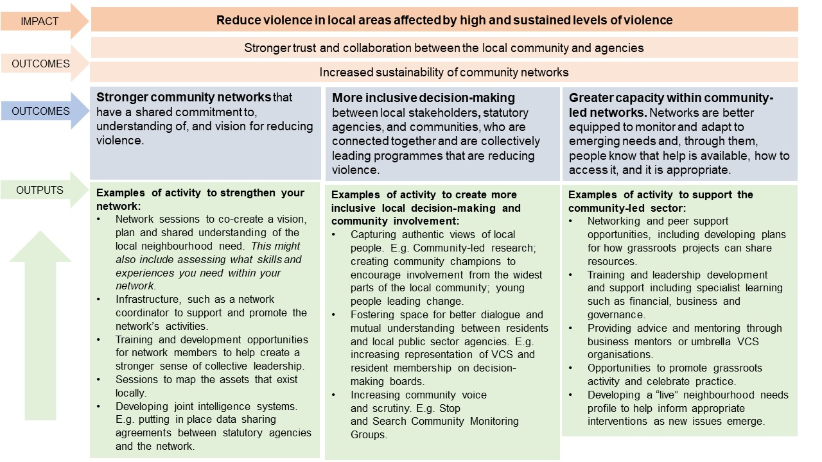

Appendix C: Data sources

- Index of Multiple Deprivation https://data.london.gov.uk/dataset/indices-of-deprivation
- London Datastore https://data.london.gov.uk/
- Public Health England “Fingertips” Public Health Profiles (e.g. Local Authority Health Profiles) https://fingertips.phe.org.uk/
- MOPAC Crime Data and Confidence and Satisfaction Dashboards https://www.london.gov.uk/what-we-do/mayors-office-policing-and-crime-mopac/data-and-statistics
- Metropolitan Police Dashboards https://www.met.police.uk/sd/stats-and-data/
- Data published by central government (e.g. Society or Crime and Justice) https://data.gov.uk/
- Local Authority Documents e.g. Community Safety Partnership Strategic Assessments, Joint Strategic Needs Assessments or Violence Strategies. The specific documents local authorities publish, but can be found on their websites

Contextual Safeguarding is an approach to understanding, and responding to, young people’s experiences of significant harm beyond their families. It recognises that the different relationships that young people form in their neighbourhoods, schools and online can feature violence and abuse. Parents and carers have little influence over these contexts, and young people’s experiences of extra familial relationships can undermine parent-child relationships. Contextual Safeguarding, Carlin Firmin 2017
In broad terms, in addition to violent behaviour, serious violence could include child criminal exploitation, gangs, use of weapons (knives, firearms etc), child sexual exploitation, sexual violence and assault, harmful sexual behaviour, trafficking, modern slavery and grooming. A vulnerable young person is one who may already be/has been involved in violence or who is at risk of being involved. Vulnerabilities can cover a range of adverse childhood experiences and/or community environments or factors, such as not being in education or living in a high violence area.

