

# **Dear Parents and Carers,**

**Join us at St James Parent and toddler group at: St James Church, East Barnet Road, New Barnet High Road EN4 8RN on the 30th July from 9.30 am – 11.00am to find out if you could be eligible for the Free 15 hours of Education for 2 years olds and how to apply.**

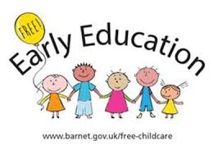

**Invitation to all Parents and Carers**

