# Due Diligence Form

## Section 1: Your Organisation

|  |  |  |  |  |  |
| --- | --- | --- | --- | --- | --- |
| Name of organisation: |  | | | | |
| Lead contact name: |  | | | | |
| Lead contact position: |  | | | | |
| Correspondence address: |  | | | | |
| Telephone: |  | | | | |
| Email: |  | | | | |
| Website: |  | | | | |
| Legal status: | Private Limited  Company | |  | Registered Charity |  |
| Public Limited  Company | |  | Public Sector |  |
| Other *(please specify)* | |  | | |
| Legal name: |  | | | | |
| Company / Charity registration number(s): |  | | | | |
| Is the organisation or any of the Directors under current or previous criminal/civil proceedings? | | ☐ No  ☐ Yes, please provide details: | | | |
| Has the organisation or its Directors been subject to a County Court Judgement (CCJ)? | | ☐ No  ☐ Yes, please provide details: | | | |
| In the last three years. has there been any finding of unlawful discrimination made against your organisation by any court or employment tribunal? | | ☐ No  ☐ Yes, please provide details: | | | |

## Section 2: Financial

|  |  |
| --- | --- |
| Has the organisation or any of its Directors’ filed for bankruptcy? | ☐ No  ☐ Yes, please provide details: |
| Have you attached your latest audited accounts or a statement of the organisation’s turnover, profit & loss/income & expenditure and cash flow position for the most recent full year of trading/operations where this information is not available in audited form? | ☐ No ☐ Yes |

## Section 3: Quality

|  |  |  |
| --- | --- | --- |
| Please list all standards and accreditations that your organisation holds or is working towards *(add rows as required):* | | |
| Name | Status | Expiration date (if applicable) |
|  | ☐ Hold ☐ Working towards |  |
|  | ☐ Hold ☐ Working towards |  |
|  | ☐ Hold ☐ Working towards |  |
|  | ☐ Hold ☐ Working towards |  |
|  | ☐ Hold ☐ Working towards |  |

## Section 4: Health & Safety

|  |  |
| --- | --- |
| Does your organisation have its own safeguarding policy? | ☐ No  ☐ Yes |
| What is the name and job title of the person responsible for child protection in your organisation? |  |
| Do you make sure that all staff and volunteers have Disclosure and Barring Service checks? | ☐ No  ☐ Yes  Please explain if not |
| How often do you repeat Disclosure and Barring Service, Disclosure Scotland or Access NI checks? |  |
| Have your staff attended Safeguarding training? | ☐ No  ☐ Yes, please state training/refresher dates: |
| How often do staff and volunteers have their safeguarding training refreshed? |  |
| How do you record and monitor reportable Incidents? |  |
| In the last three years, has there been any finding of unlawful discrimination made against your organisation by any court or employment tribunal? | ☐ No  ☐ Yes, please provide details: |

## Section 5: Policies & Documentation Checklist

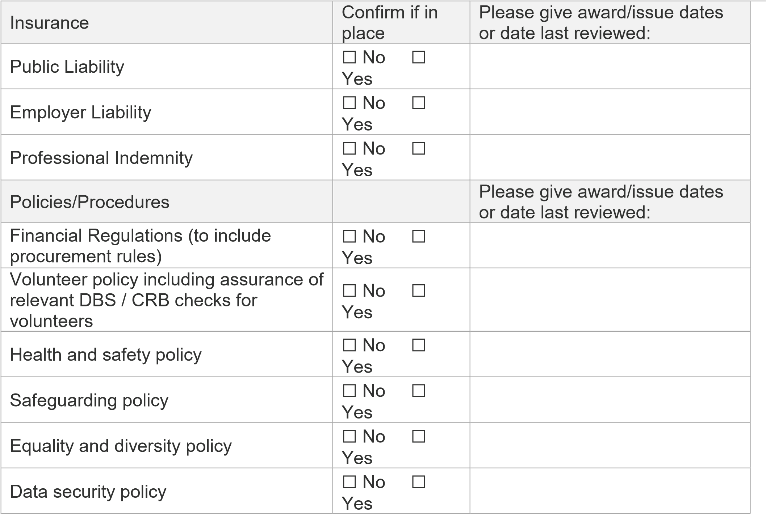

## Section 6: Declaration

|  |  |  |  |
| --- | --- | --- | --- |
| I declare to the best of my knowledge that the information provided in this Due Diligence return is reliable, accurate and true. | | | |
| Name: |  | Position: |  |
| Signature: |  | Date: |  |