
____

Building Community Power: Expanding Cooperative Housing & Community Land Trusts in London
Housing Committee
LONDONASSEMBLY

Housing Committee


The London Assembly Housing Committee examines matters relating to housing in London and leads on the scrutiny of the Mayor’s housing responsibilities. To read more about our work, please visit our website: www.london.gov.uk/who-we-are/what-london-assembly-does

Contact us

Matty Hadfield
Policy Advisor
matty.hadfield@london.gov.uk

Sarah-Jane Gay
Senior Policy Advisor
sarah-jane.gay@london.gov.uk

Joshua Hunt
External Communications Officer
joshua.hunt@london.gov.uk

Diane Richards
Committee Services Officer
diane.richards@london.gov.uk

Contents

Building Community Power: Expanding Cooperative Housing & Community Land Trusts in London 1
Housing Committee 2
Contact us 2
Contents 3
Foreword 5
Executive Summary 7
Recommendations 8
Introduction 10
London’s housing cooperatives and community land trusts 11
Features of housing cooperatives and community land trusts 13
Numbers of housing cooperatives and community land trusts in London 17
Barriers to growth 21
Financing community led housing projects 21
London Community-Led Housing Hub 28
Securing land to build or allocations of homes 31
Representation in the sector 36
Committee Activity 39
Site visit 39
Call for evidence 39
Meeting 41
Other formats and languages 42
Connect with us 43

Foreword



Sem Moema AM

Chair of the Housing Committee

London is in an acute housing crisis and fixing it will require many different approaches.
Expanding London’s Housing Cooperative and Community Land Trust sector can be one part of the solution. By being rooted in the needs of local people and communities, these projects deliver housing while building community power and encouraging a sense of belonging. They demonstrate how housing not built around profit can succeed – all while strengthening a sense of local place.

More can be done to facilitate partnership working. Our report shows how many Cooperatives and Community Land Trusts are filled with hard-working people, and there is a clear role for local authorities in facilitating connections and encouraging projects to move quickly and get built. A holistic view is also important, particularly in how the sector can help combat health and other inequalities.
However, the sector has its problems. It is currently too small – partly because there are so many barriers to projects succeeding.

It can move very slowly, with developing a single project often taking up to 15 years. Much more needs to be done to allow projects to get off the ground quickly, and our report makes suggestions as to how this can be encouraged. Bureaucracy should be removed, and creativity, partnerships and joined-up thinking encouraged between local government, Cooperative Housing and Community Land Trusts, and other stakeholders to ensure projects progress.
Availability of land to Cooperatives and Community Land Trusts is also an issue. Both the GLA and local authorities have been reluctant to release land, making it hard for community groups to get projects off the ground. Similarly, whilst a number of the Cooperatives and Community Land Trusts who we heard from through the course of this inquiry have successfully accessed upfront grant funding for feasibility studies, far too many struggle and fall at this first hurdle. More land needs to be released to community groups so more projects can be developed, and the sector expanded.

There is great scope for the Cooperative and Community Land Trust sector to demonstrate more inclusion and address wider societal issues that the stability of a permanent home can help alleviate. Whilst there are examples of good practice, the sector needs to address perceived problems around inclusion, particularly of Black and Global Majority Londoners, and working-class Londoners.

They may face systemic, cultural and financial barriers when trying to create or engage with projects, for example around allocations or funding. I am hopeful that some of the recommendations outlined in this report go some way to addressing this challenge. The Mayor’s commitment to this type of housing as part of a menu of options to tackle the housing crisis is a welcome one, and he is fully committed to stewarding public funding for the benefit of all Londoners. It is therefore incumbent on the sector to address the perception of a “closed shop”, difficult to overcome for those Londoner ambitious for their communities but with less social capital. Greater transparency around funding –who gets it, how it is publicised, and how to find out when it is available, will go a long way to tackling this perception.

Finally, there is no conceivable route out of London’s current housing crisis which does not involve treating housing as less of a commodity, and more of a human need. Housing Cooperatives and Community Land Trusts can be powerful in allowing people to have homes with a sense of belonging and control. Our report makes recommendations to help increase the sector’s impact and contribution: for this to be a success, action must be taken to ensure Cooperatives and Community Land Trusts work for all Londoners.

Executive Summary
Housing cooperatives and community land trusts offer real opportunities to help address London’s housing crisis in ways that can complement more mainstream forms of housing. These forms of community-led housing can deliver homes that are both affordable and tailored for the needs of local communities. They also produce wider benefits such as skills development.

This report presents the findings and recommendations of the London Assembly Housing Committee’s investigation into housing cooperatives and community land trusts in London.

The size of the community-led housing sector in London is small, but has grown in recent years, and with the right support can continue to do so. The barriers to growth we identify in this report are complex, but they can be overcome.

Firstly, more financial support is needed to enable housing cooperatives and community land trusts to flourish. We recommend a renewal of the GLA’s Community Housing Fund and an increase in the support available through the Affordable Housing Programme, with a public register showing which groups have received funding.

Secondly, the support provided through the London Community-Led Housing Hub needs to be extended. Housing cooperatives and community land trusts do not have the resources that larger developers do. Extending the Hub would ensure housing cooperatives and community land trusts have the help and advice they need to take on schemes.

Thirdly, housing cooperatives and community land trusts need support to access sites to deliver new homes. We recommend steps the GLA can take to ensure these groups can develop small sites for new homes, and benefit from allocations of homes on large developments.

Finally, our report addresses the diversity of the community-led housing sector. Housing cooperatives and community land trusts should be focused on meeting the needs of Londoners who can benefit most from the provision of new homes, and put real power into the hands of our diverse communities. Parts of the sector are not currently perceived as representative of London, especially for groups who are Black and from the Global Majority, as well as for those on lower incomes. We recommend recording of diversity information for funded schemes and a new strategy to increase diversity in the sector.

This report is the result of the Housing Committee investigating what benefits cooperatives and community land trusts can bring to London and Londoners, and what more the Mayor and partner organisations can do to ensure these benefits are delivered. The Committee’s report and recommendations are the result of gathering views and information from a range of experts and stakeholders, receiving evidence at two formal meetings, analysing data and conducting site visits to two local projects.

Recommendations
Recommendation 1
The GLA’s Housing and Land directorate should compile and publish a register of housing cooperatives and community land trusts allocated funding through the Community Housing Fund. The register should specify the amount and type of funding allocated to each group and the number of homes to be delivered. The register should be published by the end of 2025 and updated regularly as new allocations are made.

Recommendation 2
In the government’s upcoming spending review, the Ministry of Housing, Communities and Local Government (MHCLG) should engage with the GLA to identify new funds for housing cooperatives and community land trusts to deliver housing schemes in London.

The objective should be to renew the Community Housing Fund for the 2025-2030 period, and additional revenue funding for the Affordable Homes Programme. This would provide support for housing cooperatives and community land trusts at earlier, pre-development stages. It is important that this funding is additional and not at the expense of capital funding for other housing projects.

The government/GLA should set new targets for the delivery of homes using the additional funds, with a set number of homes to be started within the funding period.

Recommendation 3
The Mayor should identify and provide additional revenue funding to the London Community Led-Housing Hub to enable it to continue to provide support to housing cooperatives and community land trusts. The funding should be provided as soon as possible, but by no later than the start of the 2026-27 financial year, with the proposed amount to be set in the GLA’s budget for that year.

Recommendation 4
The Mayor should direct the further release of GLA Group land for housing cooperatives and community land trusts through the Mayor’s Small Sites Small Builders programme. Continued effort in this area should identify new sites every year for the remainder of the Mayor’s current term of office, with realistic targets for site and unit numbers to be defined by the GLA’s Housing and Land directorate.

The directorate should conduct a review of the programme to ensure that housing cooperatives and community land trusts can benefit from it and any barriers to their participation removed, as far as possible. We expect this review to conclude, with new targets set and some potential new sites identified, by the end of 2025-26.

Recommendation 5

The Mayor should work with housing cooperatives and community land trusts to acquire new homes under the Affordable Homes Programme.

Recommendation 6
The Mayor should direct GLA Group organisations to bring forward more opportunities for housing cooperatives and community land trusts to gain homes as part of wider developments on land they own. Continued effort in this area should identify new opportunities every year for the remainder of the Mayor’s current term of office. All proposed developments should be subject to an assessment about whether they present a viable opportunity for allocations to housing cooperatives and community land trusts. We expect the GLA’s Housing and Land directorate to be able to demonstrate that opportunities are being considered for new allocations, and that potential sites have been identified, by the end of 2025-26.

Recommendation 7
Through the London Community-Led Housing Hub, the GLA’s Housing and Land directorate should work with partners to develop a strategy by the end of 2025-26 to increase the number of housing cooperatives and community land trusts run by and for groups underrepresented in the sector, for example Black and Global Majority Londoners. This should include supporting a peer-to-peer network to allow for best practice and problem solving to be shared across the sector.

Recommendation 8
The GLA’s Housing and Land directorate should require housing cooperatives and community land trusts that receive financial support or land from the GLA to record in a standard way the demographics of residents (both tenants and/or owners) and the members of their organisation. This will help to ensure that residents and the people managing and organising schemes reflect the demographics of the local area. Information related specifically to ethnicity and income should be recorded. This system should be in place by the end of 2025-26.

Introduction

London has a housing crisis. Many Londoners – especially those who are working class and/or from minority communities – simply cannot find a safe, affordable, comfortable home for themselves and their families.
There is no single answer to this crisis. The Housing Committee has consistently pushed for increased investment in affordable homes. Thousands are delivered in London every year, but we know that more homes are needed, and they must be delivered as quickly as possible.
Many communities in London are eager to deliver their own solutions, and provide the homes that local people need. This report asks how can housing cooperatives and community land trusts contribute to tackling London’s housing crisis, especially for disadvantaged communities.
We are encouraged by the many initiatives we have heard about during this investigation. In Lewisham, the Sanford housing cooperative was created in the 1970s. Today, it houses around 125 Londoners, who have access to amenities they control like a shared garden, bicycle workshop and communal area. In Croydon, Heads2gether is a housing cooperative with an ambition to house mainly single- and low-income families, primarily from Black and Global Majority communities. It provides safe and secure accommodation and community childcare for its residents. In Ladywell, Church Grove is a community land trust development of 36 affordable homes of differing sizes, including shared ownership, affordable rent. and social rent properties. It offers a communal laundry, workspace, facilities for food growing and a guest suite.
Delivering community-led homes is not easy. Community groups need support, advice and resources in order to have a significant impact. When this has been provided, community-led housing has flourished in London. The Committee has considered how support for this approach can go further, with greater numbers of homes delivered by housing cooperatives and community land trusts, available for and controlled by the people who need them most.
As a Committee, we welcome the government’s recent announcement of a £20m investment to support community-led housing. This investment recognises the important role the sector plays in delivering the affordable homes we need.
This report identifies several important measures the Greater London Authority (GLA) and the government and others could take to enable housing cooperatives and community land trusts to help address London’s housing crisis.

London’s housing cooperatives and community land trusts

Although they form only a small part of London’s housing sector, housing cooperatives have a rich history in London, and have been supported by London local government for several decades. The majority of housing cooperatives that exist in London today were set up in the 1970s-1980s, which includes the first purpose-built housing cooperative in the UK.

Estimates we received in this investigation suggest there are several hundred housing cooperatives active in London. There are also 15 community land trusts, which we also explore in this investigation. Definitions are on page 11.
‘’In the 1970s, the policy initiatives of the GLC [Greater London Council] had created a room for co-ops to thrive, access to properties and land along with a grant went into housing co-ops, seeing them able to bring derelict properties back into use’’.
Backdoor Housing Cooperative
Written Evidence

The number of homes in this type of ownership is low compared to more mainstream forms of private and public ownership. However, there is much demand and potential for growth among cooperatives and community land trusts. Many Londoners feel that living in a housing cooperative or community land trust has huge benefits: providing an affordable long-term home with security of tenure, and community control over decisions about how it is run.

Housing cooperatives and community land trusts can develop schemes through buying or acquiring land and building homes themselves, or by buying pre-existing homes. Housing provided by these groups can be offered to rent or buy, on different types of conditions.

In this chapter we will explore information on the numbers of cooperatives and community land trusts, and the purported benefits of these models.

Definitions

Housing Cooperatives
Housing cooperatives are not-for-profit organisations democratically run for and by their members. The membership is usually only for people who live in the housing cooperative. To live in the cooperative, residents have to take an active role in providing and managing accommodation. Housing cooperatives are typically restricted in how they can sell (‘dispose’) their homes. For example, homes may have to be disposed to other cooperatives, community benefit societies, or housing charities. This ensures that once a home is cooperatively owned, it is likely to always remain in non-profit ownership. Rents set by housing cooperatives tend to be more affordable than the private rented sector. The Committee was told this is because housing cooperatives do not seek profit. And, because cooperatives rely on member participation, this can lower the cost of things like maintenance and repairs, as residents take on more of these jobs.

Community land trusts
A community land trust is a non-profit organisation, made up of local people that own and develop land for the long-term benefit of the community. Not all community land trusts deliver housing; some may provide space for businesses in the community. Housing community land trusts deliver permanently affordable homes to rent and/or buy through a legal device called an asset lock. This device means that if it is disbanded, profit will be reinvested into a similar organisation. To buy or rent a home, various requirements must be met (for example, having a household income within a certain threshold, being a community land trust member, or involvement in the local community).

Features of housing cooperatives and community land trusts

In this investigation, the Committee heard from a range of stakeholders about the features that define housing cooperatives and community land trusts, and the potential benefits of these for Londoners. A summary of these features is set out here.

Affordability

Community land trusts and housing cooperatives build affordable homes for local people, but measures of affordability are different across individual projects. For example, London Community Land Trust – a community land trust in London that has delivered two housing schemes - set rents relative to the median average income of the borough. Plum Tree Housing Cooperative sets its rents to cover necessary bills and create some reserve to cover unexpected expenses, but not to generate profit. This allows it to keep rents relatively low.

Sanford Housing Cooperative
Founded in 1973, Sanford housing cooperative is the oldest purpose-built housing cooperative in the UK. The project was started by housing activists in the late 60s, who lobbied government for five years to establish more cooperatives. Activists initially partnered with the then Greater London Council to set up Sanford in the 70s. Lewisham Council provided the land. Today, there are around 125 tenant-members living in 14 houses and a block of flats. There is a shared garden, a fully-equipped bicycle workshop, and an indoor communal area for meetings.

Benefits to the community

There are many benefits for community groups that form to create and manage housing cooperatives or community land trusts. For example, some people living in these schemes develop strong local connections, which help to combat loneliness and improves mental health and wellbeing. Coop Homes South – an organisation that supports a range of housing cooperatives – told us that ‘’the community aspects of co-ops are generally very strong with shared activities’’.

Community members involved in housing cooperative or community land trusts may develop ‘soft skills’, like project management, community organising, strategy and fundraising. In cases where the community group takes on some of the labour of the build, ‘hard skills’ may be harnessed, like carpentry, bricklaying and tiling. We also heard examples of housing cooperatives that aim to support the work of creatives; ACME provides housing and studio workspace for artists. They told us that most residents in the cooperative either strongly agreed or agreed that living alongside other artists helped them to develop their artistic careers.
‘’We believe what is central to, and distinctive about, community-led housing is resident control and belonging - that people can shape what matters most to them in their housing within a supportive community’’.
Levent Kerimol, Director
Community Led Housing London

Furthermore, people living in housing cooperatives and community land trusts actively participate in setting policies and making decisions. This creates a sense of agency and empowerment for residents, who can make decisions about the kinds of homes they want to live in.

Housing cooperatives and community land trusts also provide benefits to the wider community. There are examples in London of groups setting up events and festivals in the local area. In some schemes, there are spaces that are accessible for the general public to use and benefit from, in addition to residents of the homes.

Heads2gether Housing Cooperative
Heads2gether is housing cooperative made up of single and low-income families who live and work in Croydon. They are primarily from the Black and Global Majority. Their key aim is to provide safe and secure accommodation for their members, as well as the establishment of community childcare.

Custom design

When communities are able to design their own homes, this is done with the specific needs and wants of the community in mind. According to research by Future of London, when communities have a say in the design of their homes, considerations like energy performance and sustainability are prioritised. Furthermore, people involved in housing cooperatives and community land trusts often focus on how to create environments that facilitate community (for example, socialising), through communal spaces. We saw this first hand at the site visit to Church Grove, a community land trust in south-east London.

Reliance on volunteers

Some housing cooperatives and community land trusts rely heavily on volunteers to manage housing. In its written submission, Brandram Housing Cooperative highlighted that this can put a lot of pressure on a few individuals. It told us that dependency on a few individuals ‘increases the risk for errors to be made and mental health issues and work overload for members’. This was reiterated by Coin Street Housing Cooperative who told us, ‘‘the extensive demands on members of the primary co-operative management committees mean it can be difficult to get members to participate in their co-operative - which leaves the burden on fewer active members’’. Coop Homes South reiterated this point that many cooperatives rely on a few individuals.

Demographics

Some housing cooperatives are dedicated to specific demographics. For example, Tonic Housing in Vauxhall provides housing for older LGBTQ+ people. The housing cooperative ACME provides housing and workspaces for artists in need of affordable space and a creative community. However, many housing cooperatives do not explicitly target specific groups and, currently, there are no community land trusts in London that provide housing for specific demographics. The diversity and representation of housing cooperatives and community land trusts more broadly is discussed in the final section of this report.

Church Grove Community Land Trust
In June 2024, we visited Church Grove – a community land trust completed in 2024. The development contains 36 homes of different sizes and types of tenure, including shared ownership properties, affordable rented homes and social rented homes. To be allocated a home at Church Grove, a person must demonstrate housing need (difficulty buying or renting a home on the open market), and have a local connection to Lewisham.
Some residents of the scheme were involved in the construction of the development, and gained new skills doing so. Church Grove includes unique design features, including a communal laundry, workspace and guest suite, public access to the river, and facilities for communal food growing.
Church Grove includes a publicly accessible community space called which residents can work from or use for social activities. Church Grove has a range of design features that aim to support a low-carbon future and respond to the specific environmental circumstances of the local area. For example, the whole building is raised a metre off the ground so that the building will have no measurable impact on flood risk to neighbouring houses. There are also planters along the walkways of the scheme to create a green screen of plans that aim to reduce risk of overheating and help mitigate air pollution.

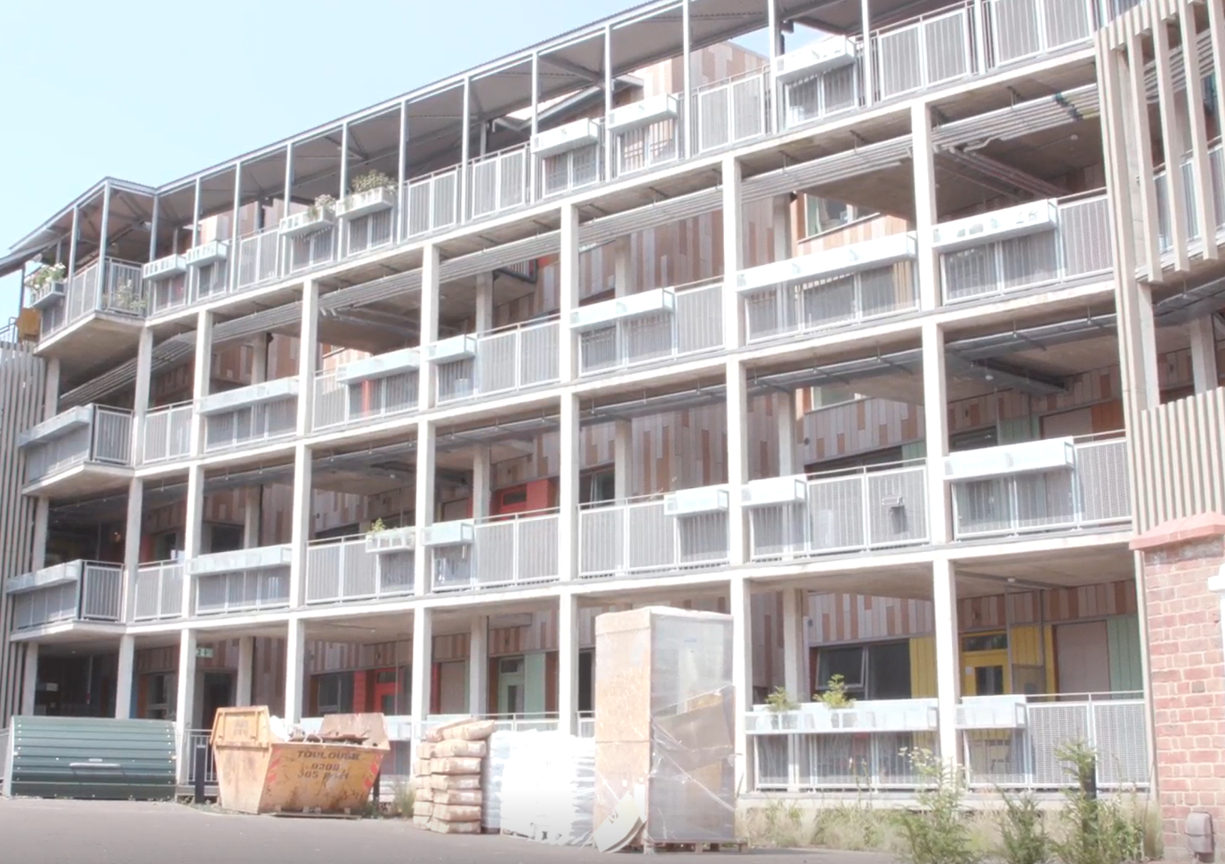
Church Grove (Source: London Assembly)

Numbers of housing cooperatives and community land trusts in London

It is not easy to find data on the number of housing cooperatives in London as there is no single register. Furthermore, the diversity of the sector means that organisations with similar purposes and activities may work and record data in very different ways.

Information provided to the Committee by the London Federation of Housing Cooperatives suggested that there are around 300 housing cooperatives of different types in London.
However, there is no definitive data on the number of existing cooperatives that are actively building or acquiring new homes.

To further explore the numbers of housing cooperatives, we consulted the Mutuals Public Register, maintained by the Financial Conduct Authority (FCA). This is a record of mutual societies registered with the FCA, including cooperative societies, community benefit societies, credit unions, building societies and friendly societies.

This register provides a dataset giving a broad indication of the sector’s size and growth in London. Figure 1 below shows the number of FCA-registered cooperative organisations in the housing sector in London. This has grown steadily in recent decades and currently numbers 628.

Figure 1: Number of FCA-registered mutuals in the housing sector, based in London, 1950-2025

Source: Financial Conduct Authority, Mutuals Public Register, accessed 24 February 2025. Chart produced by London Assembly Research Unit

Not all the organisations included in the chart above are housing cooperatives as examined in this investigation, as the register has a wider scope. Caution must be applied, given that the number of cooperatives above is around double the estimate we heard from stakeholders.

We therefore grouped the organisations according to the Standard Industrial Classification code included in the FCA register, to learn more about their activities. This breakdown is shown in Figure 2.

Figure 2: Standard industrial Classification codes of FCA-registered mutuals in the housing sector, based in London, 2025
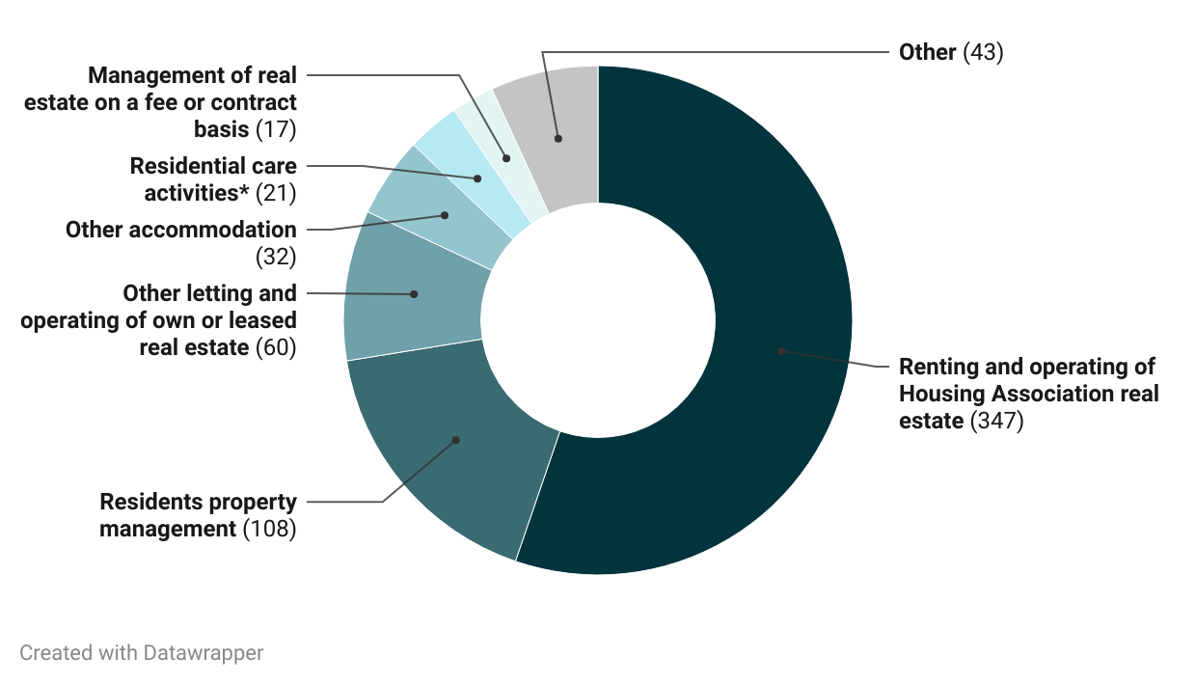
Source: Financial Conduct Authority, Mutuals Public Register, accessed 24 February 2025. Chart produced by London Assembly Research Unit. *Residential care activities for learning difficulties, mental health and substance abuse.

We also used the FCA register to identify the number of community land trusts in London. These numbers are much smaller, but also show growth. The number of community land trusts registered in London in this dataset is currently 15, with a seven-fold increase occurring between 2015 and 2020. This is shown in Figure 3.

Figure 3: Number of FCA-registered community land trusts, based in London, 2010-2025

Source: Financial Conduct Authority, Mutuals Public Register, accessed 29 January 2025. Chart produced by London Assembly Research Unit.

Barriers to growth

In London, it can be much harder to set up a housing cooperative or community land trust than it is elsewhere in the UK. Challenges such as the cost and availability of land are experienced across the country, but are even more complex in London.

‘‘Some of these projects take years and years and years to come to fruition’’.
Paul Nicholl, Triodos Bank
As a result, it is not easy for housing cooperatives and community land trusts to reach the point of starting to build a housing development in London. We heard that it can take up to 15 years for a group to develop a housing cooperative or community land trust. Despite the challenges faced by housing cooperatives and community land trusts, we have identified clear ways for Mayor and other partners to support the sector.

Financing community led housing projects
Through our investigation, we were told that access to long-term funding is a key barrier for housing cooperatives and community land trusts.
Housing cooperatives and community land trusts require both capital and revenue funding to develop housing. Capital funding is needed to fund the build of the homes, to buy existing homes, to acquire land, and to cover the costs of construction. It can also be used to subsidise the overall cost of homes so that they are on the market at a genuinely affordable price.
Revenue funding is used for the work that happens before the build, like conducting a site investigation, exploring design options, and pulling together a planning application. It could even be used for something as simple as renting out a room for a group to hold regular meetings in. There are many roles and responsibilities that may be involved in projects, which require revenue to fund. This includes the participation of architects, engineers, and solicitors.
‘‘Possibly the main challenge facing housing cooperatives is funding.’’
Bow Creek Housing, housing cooperative

There are some social investors and ethical banks that provide funding to housing cooperatives and community land trusts. However, investment in this type of housing is perceived as riskier than more established housing, as housing cooperatives and community land trusts do not have the same track record of delivering homes. Community Led Housing (also known as London’s Community-Led Housing hub – the organisation in London that provides support to community land trusts and housing cooperatives) told us: ‘’finance is harder to attract for small start-up development projects with no track record’’. This was reiterated by Battersea Tenant Cooperative, who told us: ‘’The Co-operative has found it has had difficulty finding lenders, even for relatively small sums of finance’’. Unlike councils or housing associations, housing cooperatives and community land trusts do not have an asset base to invest in new projects. This has practical consequences too: contractors are also less likely to work with housing cooperatives or community land trusts as they are seen as poorly funded organisations. To solve this, some housing cooperatives and community land trusts partner with housing associations, developers, and local authorities to deliver projects.

To be eligible for funding from local authorities, many housing cooperatives must register with the Regulator for Social Housing (to then become a registered provider) which is not an easy process to complete. Small housing organisations told us they struggled with the high cost and complex process of becoming a Registered Provider.

Mayor’s community housing fund

One available source of capital and revenue funding for housing cooperatives and community land trusts in London is the Mayor’s Community Housing Fund. In 2018, the Mayor was allocated £38m from the then Department of Levelling Up, Homes and Communities (DLUHC) to build 500 community-led homes in London. Originally, the deadline to deliver this 500 homes target was March 2023. This was extended in April 2024. However, in 2024 an extension was agreed which removed this deadline. This removal was granted by DLUHC with the provision that the GLA delivers housing through the fund as quickly as possible.
‘’In the absence of something like the Community Housing Fund, communities are not capitalised in the way that a large housing association or developer is to be able to do all that early work. You need something like the Community Housing Fund for communities to be able to do that work and bring those things forward’’.
Tom Chance, National Community Land Trust Network

Most of this funding was for capital (£30m). The remaining £8m was allocated as revenue. The Committee was told that the amount of revenue and capital the Community Housing Fund has is fixed. However, the GLA can decide how funding is used within these separate pots.
There is currently no publicly accessible register that shows the types of groups that benefit from the Community Housing Fund and the amount of funding that is allocated. However, the GLA has provided us with an overview of existing allocations.
All the revenue funding has now been allocated and as of February 2025, some £24.2m of the £30m capital funding has been allocated. However, progress has been slow against the fund’s original housing delivery target.

This shows that even with this dedicated source of funding it is hard for the community-led sector to develop housing. The removal of the deadline for delivery poses a real risk of drift and weakens the incentive for the GLA to progress completion of these 500 homes.

Figure 4: GLA Community Housing Fund – housing starts and completions, 2021-22 to 2024-25
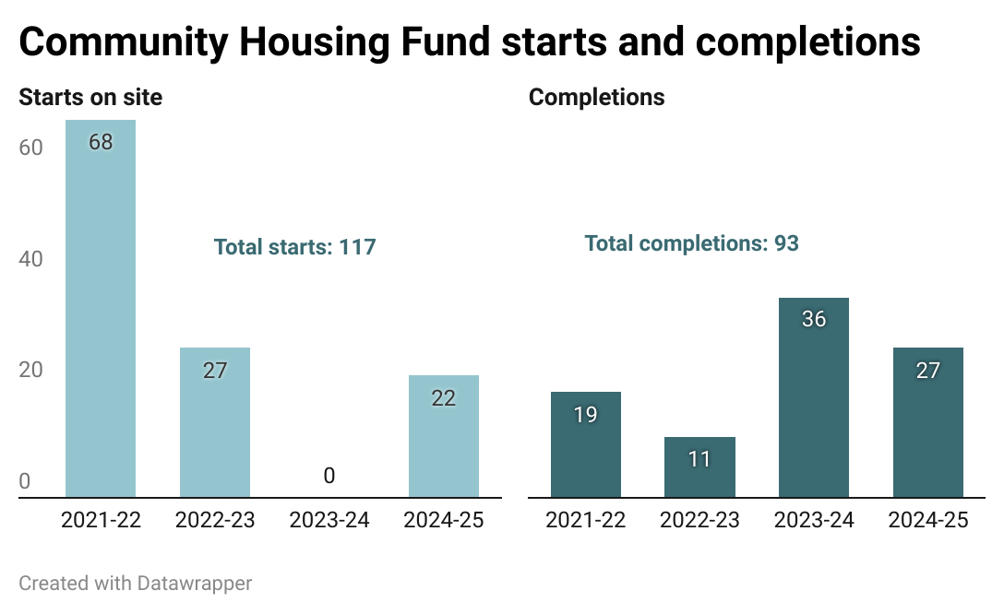
Source: Information provided by GLA, February 2025. Chart produced by London Assembly Research Unit

Figure 5: GLA Community Housing Fund – funding and allocations

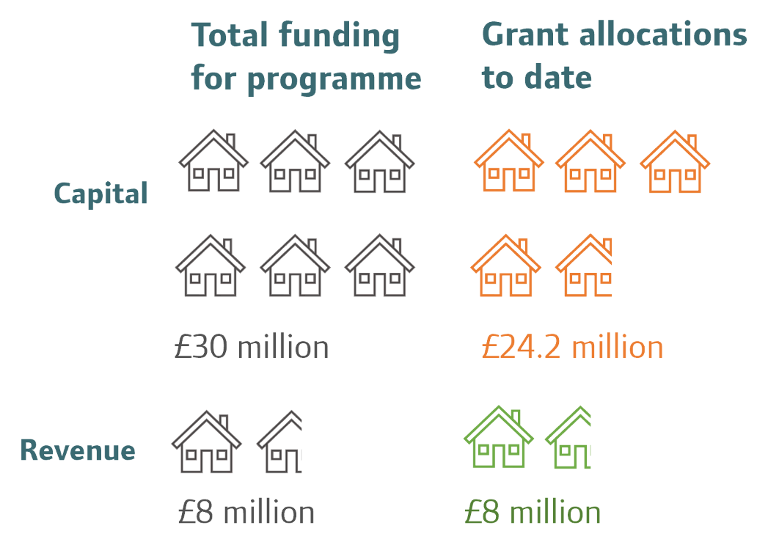

Source: Information provided by GLA, February 2025. Graphic produced by London Assembly Research Unit

Support for the fund

Through our investigation, we heard from community land trusts who have benefited from the Community Housing Fund. London Community Land Trust, for example, used revenue funding from the GLA for one of their projects to:
‘‘work with a community steering group to complete initial design study, social impact objectives, and develop a community decision and engagement plan. The funding procured a professional team to deliver development reports and cost plans…’’
The Community Land Trust Network told us that housing cooperatives and community land trusts need grant funding for things like legal and technical advice to negotiate with the council, or to figure out what a group can afford to pay for and afford to build.
‘’The GLA Community Housing Fund has been invaluable in supporting our projects, both with Revenue Grant pre-planning, and Capital Grant through to completion. Without the Community Housing Fund, it will be very difficult for small community led developers to self-fund projects, particularly without revenue funding to cover development costs pre-planning’’.
A small number of housing cooperatives told us they had benefited from the fund. Plum Tree Housing Cooperative – a group in Croydon – told us:
‘’We have received funding from London Community Housing Hub. The funding was fundamental to the creation of Plum Tree Housing Co-operative. Thanks to this support we were able to officially incorporate with FCA as a housing co-operative, receive 6 weeks co-operative training by Confederation of Co-operative Housing and to engage legal advisers’’.
We were told that the availability of revenue funding supported a diverse range of housing cooperatives and community land trusts to come forward, as the availability of funding acted as a motivator for groups.
We are pleased that there is funding specifically for housing cooperatives and community land trusts in London. Access to funding will be vital for this sector to grow and thrive. However, the Community Housing Fund is now almost fully allocated and it is not clear whether the Mayor will receive further funding from government.
In 2023, the GLA were in active discussions with government officials about the potential for additional funding for community-led housing in London. We are pleased that the Mayor has previously engaged with government on this issue. However, we are concerned that there has been no announcement from government since to increase the fund. To support the growth of the sector, the Mayor must continue to engage with government to secure additional funding. We address this issue in a recommendation for the government, later in this chapter.
We were also concerned to hear at our formal meeting that many housing cooperatives have not heard of the Community Housing Fund, and those that have find it a tough process to navigate. Further outreach work may be needed. Yet until the GLA has confirmation of additional money for the fund, it may be premature to recommend this. However, the Committee believes there is an important step that can be taken to both increase transparency and awareness: a publicly accessible register of groups that benefit from the scheme and the amount of funding that is allocated. This would enable housing cooperatives and community land trusts to see what projects are being funded and help to inform their own plans. Furthermore, analysis of the register could help identify where future outreach may be most effective.
Recommendation 1
The GLA’s Housing and Land directorate should compile and publish a register of housing cooperatives and community land trusts allocated funding through the Community Housing Fund. The register should specify the amount and type of funding allocated to each group and the number of homes to be delivered. The register should be published by the end of 2025 and updated regularly as new allocations are made.

The Affordable Homes Programme
During our investigation, we were told that access to funding through the Affordable Homes Programme could be another fruitful avenue for housing cooperatives and community land trusts.
The Affordable Homes Programme is funding from government that has been devolved to the GLA to manage. There have been two overlapping funding periods: 2016-23 and 2021-26. The 2016-23 funding period is now finished, though completions of homes are ongoing. The 2021- 26 funding period is underway. The Mayor was allocated £4bn from the previous government for the Affordable Homes Programme 2021-26.
At our formal meeting, Levent Kerimol highlighted that the Community Housing Fund has a tiny amount of capital compared to the Affordable Homes Programme. He stated, ‘’The Community Housing Fund is, what, £30 million capital compared to an AHP of about £4 billion, so that is less than 0.1 per cent’’.
Natalie Daniels, Assistant Director of Housing at the GLA, told us that several community-led housing groups are now in the process of potential approval for funding through the Affordable Homes Programme.
The Affordable Homes Programme has the potential to be a gamechanger for housing cooperatives and community land trusts. However, the way it is currently set up means it is difficult for groups to access. First, to be eligible for capital funding, a project must have reached the ‘starts on site stage’ – that is, have gained planning permission and started building. Yet groups can find it difficult to get to this stage due to limited resources, expertise, skills, and capital. This was summarised by Levent Kerimol when he said: ‘’How will you ever access capital if you do not have planning permission for it?’’.
Second, the Affordable Homes Programme does not provide groups with revenue funding. Housing cooperatives and community land trusts often need revenue to overcome the hurdles in the early stages of their projects. Natalie Daniels told us at the formal meeting that the availability of revenue funding is vital for less mainstream housing providers, like supported housing or community-led housing groups. She recognised that diversity in housing supply is important to address the range of housing needs, and told us that ‘’the fact that we [the GLA] do not have revenue funding as part of the AHP is a limiting factor to some of that’’.
The GLA has historically engaged with government to lobby for revenue funding through the Affordable Homes Programme, but has not yet been successful.
The Community Housing Fund and Affordable Housing Programme are two important funding sources for housing cooperatives and community land trusts to deliver new housing schemes. While the GLA manages these funds, the amount and type of resource available are a matter for the government. The Committee wants to see both sources of funding available and suggest a strategic assessment is undertaken of both and the total amount of resource for community-led schemes is increased. Continuing discussions ahead of the government’s spending review, expected in June 2025, present a good opportunity to do this. We would also welcome creating new targets for the delivery of homes using these funds, with specific end dates. The GLA can then be held to account against these.
Recommendation 2
In the government’s upcoming spending review, the Ministry of Housing, Communities and Local Government (MHCLG) should engage with the GLA to identify new funds for housing cooperatives and community land trusts to deliver housing schemes in London.

The objective should be to renew the Community Housing Fund for the 2025-2030 period, and additional revenue funding for the Affordable Homes Programme. This would provide support for housing cooperatives and community land trusts at earlier, pre-development stages. It is important that this funding is additional and not at the expense of capital funding for other housing projects.

The government/GLA should set new targets for the delivery of homes using the additional funds, with a set number of homes to be started within the funding period.

London Community-Led Housing Hub

The London Community-Led Housing Hub (the Hub) provides support to housing cooperatives and community land trusts in London. It is funded through the Community Housing Fund. The early-stage revenue from the Community Housing Fund was allocated to housing cooperatives and community land trusts through the Hub. Through our investigation, we heard that the Hub has provided invaluable support to community land trusts and housing cooperatives.
Nationally, there are several organisations (some funded by charities, others by government funding) that provide free guidance and support for housing cooperatives and community land trusts. These ‘enabler hubs’ offer help at the early stages of a project. The support they provide includes technical support, partnerships (for example, linking up groups with funders or housing associations), capacity building (skills), and advice and mentoring. This ensures that groups can access the information needed to navigate a very complex system. The London Community-Led Housing Hub is London’s enabler hub.
“It is very challenging. We want to do as much as we can on our side, from the Mayor, to support, and we do through the Community Housing Fund, which provides both capital and revenue funding, and through the hub, which provides a lot of advice and support for groups who, as we have heard, come together without that big development expertise that the larger organisations have.”

Deputy Mayor of London for Housing and Residential Development, Tom Copley

Enabler hubs have been seen as important to the growth and success of community-led housing groups led by Black and Global Majority groups. In our investigation we heard that ‘’enabling hubs and national infrastructure bodies are important partners and allies to black and minority ethnic communities’’.
In London, the Hub provides support to community-led housing groups (including housing cooperatives and community land trusts), local authorities, housing associations and developers to help set up community housing projects in London.
The Hub provides mentoring and advice for housing cooperatives and community land trusts at the early stages, including advice on development, partnership, and acquisitions. This includes support with site identification, planning applications, fundraising, and applications to the Community Housing Fund.

Support for community groups
Housing cooperatives and community land trusts need support and guidance across all stages of their projects. Guests at the formal meeting highlighted that they require significant support at the pre-development stages (the stages before the building of homes starts). Levent Kerimol, director of Community Led Housing London, told us that: ‘’a load of work needs to happen’’ at these early stages, like ‘’…securing sites, getting planning, even doing some of the pre-tender work and getting contractors on board’’.
Through our investigation, we received positive evidence about the Hub’s support for housing cooperatives and community land trusts at early stages of projects. For example, Rode Housing Cooperative – a cooperative exploring options to convert underused properties around London – stated that: ‘’’…we had amazing help, support, and small amounts of funding from the London Community Housing Hub. We learnt a great deal from this…’’. . NW3, a community land trust in north London, told us that: “For our CLT [Community Land Trust], a key enabler to help us start-up and progress was The Community Led Housing Hub”.
Although stakeholders were generally positive about the Hub, one response outlined concerns – both with the hub and the wider sector – about equity for Black and Global Majority groups. We cover this in the final section.
In August 2024, it was reported that the Hub has supported 57 organisations to progress 61 projects. Of the 117 homes which have been supported by the Community Housing Fund to start on site, five of the six groups involved (83 per cent) have received support from the Hub.

Support for local councils
The Hub also provides practical support and advice to boroughs to create opportunities for housing cooperatives and community land trusts. Since 2018, it has supported 16 London boroughs to develop community-led housing schemes.
The evidence we received from local authorities highlighted that councils face a range of barriers – sometimes specialist skills, often funding and resource/capacity – to support them. For example, in response to our call for evidence, Enfield Council stated that the council would benefit from support to develop in-house specialist skills, to be able to better support housing cooperatives and community land trusts. It also told us that financial pressures limit the ability of councils to support them.
We received evidence from some housing cooperatives and community land trusts that identified lack of expertise or capacity in the council as a hinderance to the development of their projects. For example, Plum Tree Housing Cooperative told us:
‘‘When we approached our local council four years ago, they claimed to have no knowledge what housing co-operatives are. They were quite reserved to the idea of working with one on the account that they have never done it before and didn’t have necessary experience or legal contracts that they could use.’’
The Hub can mitigate these issues for councils – for example, through increasing resource for a particular community-led housing project or providing the council with expert advice. Brent Council told us that without the support from Community Led Housing London, it is unlikely that the community land trust in their borough would have got to the stage it has.
The hub received revenue funding through the Mayor’s Community Housing Fund, however this fund has now been fully allocated with no further funding announced (as of March 2025). Through this investigation, we were told that, given the uncertainty of future funding from government, the Hub is now moving towards a consultancy approach whereby organisations pay for its service. As the Hub has been providing a valued service to housing cooperatives and community land trusts, we believe that the Mayor should continue resourcing the Hub so it can again provide free advice and support for these projects. Recommendation 2 above addressed the funds available to support housing cooperative and community land trust schemes. We also conclude it is necessary to specifically guarantee the future of the Hub in London as a key enabler of these schemes.

Recommendation 3
The Mayor should identify and provide additional revenue funding to the London Community Led-Housing Hub to enable it to continue to provide support to housing cooperatives and community land trusts. The funding should be provided as soon as possible, but by no later than the start of the 2026-27 financial year, with the proposed amount to be set in the GLA’s budget for that year.

Securing land to build or allocations of homes

Land to build

Land is more expensive for housing cooperatives and community land trusts in London than in other areas of the UK. At our formal meeting, Niall Mulholland (London Federation of Housing Cooperatives) told us that high land costs are the main barrier for housing cooperatives. This was reiterated by housing cooperatives and community land trusts that submitted written evidence. Therefore, housing cooperatives and community land trusts rely on the council to gift them land or provide it to them at a reduced cost. Some housing cooperatives and community land trusts partner with housing associations in order to acquire land.

According to research by Future for London, housing cooperatives and community land trusts can deliver affordable homes on sites that do not work for traditional developers, such as large housing associations or private developers. This can include ‘infill’ development, which describes the construction of buildings on unused land located within urban or otherwise developed areas, or small sites. However, small sites can be difficult for housing cooperatives and community land trusts to develop.

Some councils are interested in how housing cooperatives and community land trusts can build on land ignored by traditional developers. However, we were told by Lewisham Council that the gifting land or selling it at a discounted rate to housing cooperatives and community land trusts is difficult at present. This is due to competing priorities to deliver the council’s own housing programme. CASH told us they had been in conversations with Lewisham Council regarding a collection of small sites they were looking to dispose of, but ‘‘they have now said they will no longer be gifting land (£1) to CLTs [community land trusts]’’.

Through our call for evidence, some housing cooperatives and community land trusts supported the release of small sites for the sector. The Mayor’s ‘Small Sites, Small Builders’ programme aims to make more publicly owned land available for smaller housing providers, including housing cooperatives and community land trusts. However, out of 59 sites that have come through the programme, only two community land trusts secured sites.

Responses to our call for evidence highlighted that small sites are very difficult for housing cooperatives and community land trusts to develop. London Community Land Trust told us:

‘’…often sites proposed by GLA/TfL or Local Authorities are very challenging and result in complex projects. While accepting development in London is often difficult, if better and larger sites were brought forward for community led housing, then delivery would be more economic, faster and provide more homes’’.

The Community Land Trust Network echoed this and stated that developing small sites is ‘’an extremely complicated process that requires a great deal of expertise, free time, and access to finance’’. Furthermore, Backdoor Housing Cooperative told us that ‘’access to land for development is too complex an undertaking for most housing co-ops unless professional help is outsourced’’.

The Committee wants to see a further release of publicly owned land for development by housing cooperatives and community land trusts. We recognise the complexities often encountered when developing small sites, but believe these can still offer an important opportunity for housing cooperatives and community land trusts. This is especially the case if the other recommendations of this report are implemented, to increase the resources and support available to housing cooperatives and community land trusts.

Recommendation 4
The Mayor should direct the further release of GLA Group land for housing cooperatives and community land trusts through the Mayor’s Small Sites Small Builders programme. Continued effort in this area should identify new sites every year for the remainder of the Mayor’s current term of office, with realistic targets for site and unit numbers to be defined by the GLA’s Housing and Land directorate.

The directorate should also review the programme to ensure that housing cooperatives and community land trusts can benefit from it and any barriers to their participation removed, as far as possible. We expect this review to conclude, with new targets set and some potential new sites identified by the end of 2025-26.

Allocations of homes on larger sites

Through our investigation, we were told one way for housing cooperatives and community land trusts to succeed is to acquire (buy) existing homes. One benefit of this approach is that it allows housing cooperatives and community land trusts to bypass some of the challenges related to developing sites. Community Led Housing London told us that ’’a widespread requirement to ensure a proportion of larger schemes are transferred to CLH [community led housing] would allow better processes to develop’’.

There have already been successful examples of this approach working in London: in the early 2010s, London Community Land Trust partnered with the developer Linden Homes to deliver 23 Community Land Trust Homes at the former St Clements Hospital site in Mile End. For this scheme, section 106 planning obligation required 35 per cent of the homes to be affordable, including 58 for social rent and 23 Community Land Trust homes, which were made available for sale. This scheme was built in partnership with the GLA, the housing association Peabody and the property developer Linden Homes, and was London Community Land Trust’s first successful housing scheme.

The allocation of affordable homes enables housing cooperatives and community land trusts to bypass some difficulties associated with development. However, this process may limit the extent to which the community group has control over its homes. For example, residents living in the community land trust properties of the St Clements site are not in control of how their homes are managed; the site is managed by a resident management company. Furthermore, partnership with a developer or housing association may also limit the extent to which a housing cooperative or community land trust can develop the housing they want.

At our first meeting, Tom Copley, Deputy Mayor of Housing and Residential Development told us that the specific requirements of the Community Housing Fund make it challenging to fund the acquisition of existing homes for housing cooperatives and community land trusts. However, the Mayor could also support community land trusts and housing cooperatives to acquire homes through the Affordable Homes Programme which can fund acquisitions. So far, 14 per cent of homes delivered through the programme have been done in this way. We believe the Mayor should use acquisitions made through Affordable Homes Programme to help housing cooperatives and community land trusts grow.

Recommendation 5
The Mayor should work with housing cooperatives and community land trusts to acquire new homes under the Affordable Homes Programme.

Acquiring housing through Section 106

Although small-scale, housing cooperatives and community land trusts plays a role in providing forms of social housing in our city. In London, around two-thirds of community land trust homes are for social rent and allocated according to housing need. In 2022, it was estimated that around 100 housing cooperatives are registered providers of social housing (this means cooperatives can provide social rented homes and are regulated by government).

As illustrated with the example of St Clements above, developers usually meet section 106 obligations by selling the required number of homes to another organisation. This then provides them to Londoners on an affordable basis. ACME is a housing cooperative that provides affordable living and studio space for artists in economic need. Its most recent scheme was bought through a section 106 requirement to provide affordable space within a student housing scheme.

One way for housing cooperatives and community land trusts to acquire homes is through buying these homes from developers to then rent out at a sub-market price. We heard about some examples of groups that benefited from buying section 106 home from larger housing schemes. Dr Tom Moore told us that section 106 has great potential for community-led housing groups:

‘’…capitalising or tuning in to the debate around section 106 contributions could be a really fruitful avenue. If we are talking about practical actions and things that could be embedded into plans and policies, there are community-led housing groups around the country that have benefitted either from being part of delivering the section 106 affordable housing element of a scheme…’’.

However, a difficulty in using section 106 is that for housing cooperatives and community land trusts to purchase homes through section 106, they must be a registered provider. This registration is a very complex process for housing cooperatives and community land trusts, and smaller housing organisations more generally. For example, Gida Housing Cooperative told us that they have struggled to become a registered provider:

‘’Gida is currently working towards the conditions needed to enter into the sale of 58 units - primarily the need to become a Registered Provider (RP) for social housing. The challenges relate to governance and the load on the Committee to navigate this complex process, the specialist support needed, and the significant costs associated with that support’’.

Deputy Mayor Tom Copley told us that some groups will partner with housing associations if they are not registered providers, so that they can manage the social rented units of a scheme. He went on to give the example of a small housing association in south-east London that partnered with the Deptford Ragged Trust – a charitable trust of a church – to deliver a community-led housing project.

This sale of 58 homes is part of the St Anns development on an old hospital site in Haringey, which was purchased which was purchased by the Mayor in 2018. The housing development will consist of 995 homes and is being developed through a partnership between the Mayor and the housing association Peabody. According to the GLA, up to 56 of these homes have been put aside for community-led homes.

At our formal meeting, we were pleased to hear the GLA is taking action to identify the challenges small housing organisations (including community-led housing groups) face to become registered providers, and that this is limiting. Deputy Mayor Tom Copley told us the GLA plans to convene a group to discuss these barriers for small housing organisations. Deputy Mayor Tom Copley told us:

‘’I am going to be convening a group to come together to discuss, hopefully with the regulator, the barriers to small organisations becoming RPs. We are very conscious of that. Also, we are very keen to promote a diversity of organisations that can take on section 106 units because the large RPs at the moment, for various reasons, are not particularly interested in doing so’’.

It is promising that the Deputy Mayor for Housing is engaging with the sector to make it easier for smaller housing organisations – such as housing cooperatives and community land trusts – to become registered providers. We look forward to seeing the outcome of this engagement.

The Deputy Mayor was positive about this model and told us that it should be replicated. He went on to say that this is ‘’probably something that the [GLA] should explore further, both on GLA-owned sites and through Places for London as well’’.

Recommendation 6
The Mayor should direct GLA Group organisations to bring forward more opportunities for housing cooperatives and community land trusts to gain homes as part of wider developments on land they own. Continued effort in this area should identify new opportunities every year for the remainder of the Mayor’s current term of office, with all proposed developments subject to an assessment about whether they present a viable opportunity for allocations to housing cooperatives and community land trusts. We expect the GLA’s Housing and Land directorate to be able to demonstrate that opportunities are being considered for new allocations, and that potential sites have been identified, by the end of 2025-26.

Representation in the sector

Housing cooperatives and community land trusts are sometimes perceived as benefiting certain demographics, typically seen as White and middle-income. Yet there is limited quantitative evidence to demonstrate this, as not all housing cooperatives or community land trusts record the demographics of residents.

There has been limited research carried out on the diversity and inclusion of the community-led housing sector in London. However, in recent years, research suggests that Black and Global Majority people, low-income people and people with disabilities may find it harder to participate in community-led housing. This is both in terms of creating and living in a housing cooperative or community land trust.

There are many examples of long-standing community-led housing schemes, including housing cooperatives, providing homes to groups that face barriers in the housing sector. There is a particularly strong history, for example, of housing cooperatives led by and for Black and Global Majority communities in London. Fusions Jameen in Lewisham is one example – a Black and Global Majority-led, self-build cooperative who built 13 sustainable timber frame homes in the 1990s, known as Nubia Way. There are also some newly emerging Black and Global Majority led housing cooperatives in London – such as Heads2getha Cooperative, Gida Housing Cooperative and Elevation Mutual Housing Community Cooperative.

We recognise the opportunities housing cooperatives and community land trusts offer for groups that struggle in the housing sector. We urge the Mayor to ensure that these groups can benefit from the opportunities this tenure presents.

The history / benefits to Black and Global Majority groups

There are examples of community-led housing being tied up in struggles for social change and movements led by minoritised groups. The community land trust movement, for example, started off in the US as part of the civil rights movement. There is a rich history of Black and Global Majority participation in community-led housing, which is demonstrated through many long-standing and successful housing cooperatives in London. Many of these schemes benefited from funding opportunities in the 1980s and 1990s, that provided targeted funding to Black and Global Majority housing associations and housing cooperatives.

According to research from the University of Liverpool, Black and Global Majority people are often marginalised from decisions over land use and housing development. Community-led housing is a way to ‘’extend power and participation, as well as provide more secure and affordable housing’’. Zahra Housing Cooperative – a cooperative that tried but was not successful in building homes for multi-generational families from South Asian Backgrounds – told us, ‘’Housing Cooperatives can be the sector that provides housing for specific group of people that cannot achieve adequate housing through the private or public sector’’.

Barriers for underrepresented groups

Developing a housing cooperative or community land trust is difficult for all community-led housing groups. However, some research suggests that these barriers are even more difficult for Black and Global Majority groups. In qualitative research submitted by the University of Liverpool, Black and Global Majority groups highlighted ‘’experiences of exclusion from decision-making and opportunities in their local context, such as difficulties in engaging with local authorities or funding bodies’’. The previous chair of Nubia Way told us that despite the interest in and demand for Black and Global Majority-led self-build cooperative schemes, ‘’there is no proactive strategy to bring together the various stakeholders’’.

Furthermore, a lack of access to funding may be particularly detrimental to the success of Black and Global Majority community-led housing groups. In research conducted with banks and charities that lend or allocate capital to community-led housing groups, it showed there is a lack of targeted and proactive engagement with a range of community-led housing groups to share funding opportunities. Instead, these bodies rely on pre-existing networks of community-led housing groups which Black and Global Majority people perceive themselves to be under-represented in.

One way that community land trusts acquire land is through a local authority either gifting land or providing it at a discount. However, in research conducted by the Young Foundation, it states that among Black and Global Majority groups and people from working-class backgrounds, there is a lack of trust in local authorities. This is due to previous experiences where groups have felt a lack of support from them.

Representation

There is a perception that housing cooperatives and community land trusts cater to White and middle-income people in the housing sector. This is despite the opportunities that community-led housing could offer to under-represented groups. Some groups may be underrepresented in the sector because they do not have the time to dedicate to building and managing homes (for example, if you are a person with caring responsibilities). Some researchers suggest that White and middle-income people are overrepresented in community-led housing because the opportunities for living in community land trusts or housing cooperatives are shared through White and middle-income social groups. This was point was made by the cooperative Collective Ownership society, who told us:

‘’Currently the time and expertise required to start a new CLH [community led housing] project, as well as the chances of success, discourage anyone looking to live in CLH, and inevitably certain disadvantaged demographics are more greatly affected’’.

However, there is lack of quantitative data to support this. Housing cooperatives and community land trusts should record the demographics of schemes to improve transparency and allow for a targeted approach to grow certain types of community-led housing.

There is also a lack of diversity across people that occupy leadership positions in the community-led housing sector. In research conducted by The Young Foundation, researchers stated that more needs to be done to increase the number of people that occupy professional roles in the sector ‘’who have disabilities, are from ethnic minority backgrounds, and low socioeconomic backgrounds’’.

Recommendation 7
Through the London Community-Led Housing Hub, the GLA’s Housing and Land directorate should work with partners to develop a strategy by the end of 2025-26. This will aim to increase the number of housing cooperatives and community land trusts run by and for groups underrepresented in the sector, for example Black and Global Majority Londoners. It should include supporting a peer-to-peer network to allow for best practice and problem solving to be shared across the sector.

Recommendation 8
The GLA’s Housing and Land directorate should require housing cooperatives and community land trusts that receive financial support or land from the GLA to record in a standard way the demographics of residents (both tenants and/or owners) and the members of their organisation. The aim is to ensure that residents and the people managing and organising schemes reflect the demographics of the local area. Information related specifically to ethnicity and income should be recorded. This system should be in place by the end of 2025-26.

Committee Activity

Terms of reference:

Our investigation sought to:
- Examine how community land trusts and housing cooperatives operate in London.
- Identify the key opportunities and challenges relating to this sector and the extent to which the Mayor has provided support for community land trusts and housing cooperatives.
- Explore what further opportunities there are for the Mayor to support community land trusts and housing cooperatives.
- Identify the extent to which community land trusts and housing cooperatives support communities in London to access housing, understanding which demographics benefit from these schemes.

As part of the investigation, we ran a Call for Evidence, visited two community in south-east London, and held a formal evidence session with key stakeholders. (See details of this Committee activity in the Annex of this report).

Site visit

On 26 June 2024, the Housing Committee carried out a site visit to two CLTs in south-east London: Citizens House and Church Grove. Our purpose was to see recently completed CLT sites in London, and to hear directly from organisers about the development and operation of Citizens House and Church Grove.

Call for evidence

The Housing Committee ran a public call for evidence in July and August 2024. We received 42 responses from:

Housing Cooperatives
ACME
Backdoor Housing Cooperative
Battersea Tenants Cooperative
Bow Creek Moorings
Brandrams Housing Cooperative
Coin Street Secondary Housing
Collective Ownership Society
Coop Homes South
Consortium of London Short-Life Coops
Elevation Mutual Housing Community
Gida Housing Cooperative
Green Dragon Lane Coop
Heads2getha Housing Cooperative
Moss Mutual Home Ownership Society
Plum Tree Housing Cooperative
Rode Housing Cooperative Limited
Sanford Housing Coop
St Marks Short Life Housing Cooperative
Westminster Housing Coop
Zahra Housing Cooperative

Charities
Bow Arts
Caledonian Foundation

Housing Associations
CHISEL housing
Cooperation in Social Housing Commission
London Federation of Housing Cooperatives
Poplar HARCA
UK Cohousing Network

Community Led Housing Networks and Associations
Community Led Housing
Community Land Trust Network
Consortium of London Short-Life Coops
Cooperation in Social Housing Commission
London Federation of Housing Cooperatives

Local councils
Enfield council
Lewisham council
Brent council

Policy, Advocacy and Academics
Joint submission from Dr Tom Moore, Claude Hendrickson MBE, Henri Baptiste, Dr Yael Arbell

Individuals
Andrew Watson, CHISEL Independent Shareholder
John Clark, Housing Consultant
Tim Oshodi, Nubia Way

Community Land Trusts
Community Assets for Society and Housing
NW3 Community Land Trust
Community Land Trust Gent
London Community Land Trust
London Trades Guild CLT
Brent CLT

We received a follow up letter from Tom Copley following its meeting in July 2024.

The responses from the call for evidence were used to inform this report. The full collated responses have been published alongside this report

Meeting

The Housing Committee meeting on 24 July 2024 heard from the following guests:

Panel 1:
- Tom Chance, Chief Executive of the Community Land Trust Network
- Niall Mulholland, Executive Member of the London Federation of Housing Cooperatives
- Fatimatu Mohamed, Secretary, Gida Housing Cooperative
- Bernadette Marjoram, Board Member, Meridian Home Start

Panel 2:
- Tom Copley, Deputy Mayor for Housing and Residential Development, GLA
- Dr Tom Moore, Senior Lecturer in Planning, University of Liverpool
- Natalie Daniels, Assistant Director of Housing, GLA [virtual]
- Levent Kerimol, Project director at Community Led Housing London
- Paul Nicoll, Head of Societal Lending, Triodos Bank

Other formats and languages

If you, or someone you know needs this report in large print or braille, or a copy of the summary and main findings in another language, then please call us on: 020 7983 4100 or email assembly.translations@london.gov.uk



Connect with us

The London Assembly
City Hall
Kamal Chunchie Way
London E16 1ZE

Website: https://www.london.gov.uk/who-we-are/what-london-assembly-does
Phone: 020 7983 4000



Follow us on social media



Press release, Government paves the way for local people to build more homes, 25 March 2025
London Assembly Housing Committee, Transcript of Agenda Item 9, Panel 1
Backdoor Housing Cooperative, call for evidence submission
GLA briefing on Community Land Trusts and Cooperative Housing
London Assembly Housing Committee, Transcript of Agenda Item 9, Panel 1
London Assembly Housing Committee, Transcript of Agenda Item 9, Panel 1
GLA briefing on Community Land Trusts and Cooperative Housing
The London Cooperative Housing Group, Co-operate not speculate, 2017
Community Land Trust Network, What is a Community Land Trust? accessed 4 Feb 2025
London Trades Guild, call for evidence submission.
Community Land Trust Network, A to Z – Jargon Buster, accessed 4 Feb 2025. Community Land Trust Network,
London Community Land Trust, call for evidence submission. Information submitted to the Committee by the Rural Synthesis Society on 1 July 2024.
London CLT, About, accessed 29 Jan 2025
London Community Land Trust, call for evidence submission
Plum Tree Housing Cooperative, call for evidence submission
Sanford Housing Cooperative, About Sanford
Sanford Housing Cooperative, call for evidence submission
Sanford Housing Cooperative, call for evidence submission
Sanford Housing Cooperative, About Sanford
Future of London, Foundations for Community Led Housing, 2019. London Community Land Trust, call for evidence submission. UK Cohousing Network, call for evidence submission
Coop Homes South, call for evidence submission
Future of London, Foundations for Community Led Housing, 2019
ACME, call for evidence submission
Community Led Housing, call for evidence submission
The London Cooperative Housing Group, Co-operate not speculate, 2017
Future of London, Foundations for Community Led Housing, 2019. St Marks Short Life Housing Cooperative, call for evidence submission.
Future of London, Foundations for Community Led Housing, 2019
Information submitted to the Committee by the Rural Synthesis Society on 1 July 2024.
Community Led Housing London, Heads2Gether, accessed 24 February 2025
London Assembly Housing Committee, Transcript of Agenda Item 9, Panel 1
Future of London, Foundations for Community Led Housing, 2019
Future of London, Foundations for Community Led Housing, 2019
Brandrams Housing Cooperative, call for evidence submission
Coin street Housing Cooperative, call for evidence submission
Coop Homes South, call for evidence submission
Tonic Housing, accessed 17 March 2024
ACME, call for evidence submission
Community Led Housing London, Church Grove, RUSS, accessed 4 February 2025
Information submitted to the Committee by the Rural Synthesis Society on 1 July 2024.
Church Grove Community Benefits, 21 November 2020
Church Grove Community Benefits, 21 November 2020
Church Grove Community Benefits, 21 November 2020
This dataset includes all organisations with a Greater London address in the Financial Conduct Authority’s Mutuals Public Register with the Reporting Classification ‘Housing’. Values are for the number of organisations registered at the end of each calendar year (except for 2025 which is to 24 February 2025), with the number of deregistered organisations subtracted.
This dataset includes all organisations with a Greater London address in the Financial Conduct Authority’s Mutuals Public Register with the Reporting Classification ‘Housing’. Values are for the number of organisations registered at the end of each calendar year (except for 2025 which is to 24 February 2025). For ease of presentation, several categories with low numbers of entries have been group as ‘Other’. For more information on Standard Industrial Classification codes please visit: https://resources.companieshouse.gov.uk/sic/
This dataset includes all organisations with a Greater London address in the Financial Conduct Authority’s Mutuals Public Register, with the Reporting Classification ‘Community Land Trusts’. Values are for the number of organisations registered at the end of each calendar year (except for 2025 which is to 29 January 2025), with the number of deregistered organisations subtracted.
London Assembly Housing Committee, Transcript of Agenda Item 9, Panel 2
London Assembly Housing Committee, Transcript of Agenda Item 9, Panel 2
Capital funding is used to buy existing homes, purchase land, or to cover the costs of building homes. Revenue funding is used at the early stages of community-led housing projects, for things like planning applications or investigating sites to build the homes.
London Community Land Trust, call for evidence submission
Community Led Housing London, Development options and process, August 2020
Bow Creek Housing, call for evidence submission
Community Led Housing, call for evidence submission
Community Led Housing, call for evidence submission
Battersea Tenants Cooperative, call for evidence submission
Community Led Housing, call for evidence submission
Community Led Housing, call for evidence submission
Cooperatives London, ‘Housing Co-ops’, accessed 19 November 2024
Gida Housing Cooperative, call for evidence submission
MD2372 Community Housing Fund, 19 December 2018
GLA briefing on Community Land Trusts and Cooperative Housing
London Assembly Housing Committee, Transcript of Agenda Item 9, Panel 1
GLA briefing on Community Land Trusts and Cooperative Housing
London Community Land Trust, call for evidence submission
London Assembly Housing Committee, Transcript of Agenda Item 9, Panel 1
London Community Land Trust, call for evidence submission
Plum Housing Cooperative, call for evidence submission
Community Led Housing, call for evidence submission
London Assembly Housing Committee, Transcript of Agenda Item 9, Panel 1
Moss Mutual Home Ownership society, call for evidence submission
London Assembly Housing Committee, Transcript of Agenda Item 9, Panel 2
It was not specified whether these groups were housing cooperatives or community land trusts
London Assembly Housing Committee, Transcript of Agenda Item 9, Panel 2
London Assembly Housing Committee, Transcript of Agenda Item 9, Panel 2
London Assembly Housing Committee, Transcript of Agenda Item 9, Panel 2
London Assembly Housing Committee, Transcript of Agenda Item 9, Panel 2
Community Led Homes, ‘London Community Led Housing Support Hub’, accessed 19 November 2024
London Assembly Housing Committee, Transcript of Agenda Item 9, Panel 2
University of Liverpool, call for evidence submission
Community Led Housing London, ‘about us’, accessed 19 November 2024
Community led housing London, about us’ accessed 19 November 2024
MQT, 2024/1008
London Assembly Housing Committee, Transcript of Agenda Item 9, Panel 2
London Assembly Housing Committee, Transcript of Agenda Item 9, Panel 2
Rode Housing Cooperative Limited, call for evidence submission
NW3 CLT, call for evidence submission
Tim Oshodi, Nubia Way, call for evidence submission (unpublished)
Letter from Tom Copley to the Housing Committee, 14 August 2024
Community led housing London, ‘our support to councils and others’, accessed 19 November 2024
Information provided directly to the Scrutiny Team on 13 December 2024. The sixteen boroughs and LLDC received more than 5 hours of support from London Community-led Housing.
Poplar HARCA, call for evidence submission
Enfield Council, call for evidence submission
Plum Tree Housing Cooperative, call for evidence submission
Brent Council, call for evidence submission
London Assembly Housing Committee, Transcript of Agenda Item 9, Panel 2
London Assembly Housing Committee, Transcript of Agenda Item 9, Panel 1
Community Assets for Society & Housing (CASH), call for evidence submission
Future for London, Foundations for Community-Led Housing, 2019
Future for London, Foundations for Community-Led Housing, 2019
Lewisham council, call for evidence submission
Community Assets for Society and Housing, call for evidence submission
Elevation Mutual Housing Community, London Community Land Trust, Community Land Trust Network, Community Assets for Society & Housing (CASH), call for evidence submissions
GLA, ‘Making small sites available to small builders’, accessed 26 November 2024
GLA briefing on Community Land Trusts and Cooperative Housing
London Assembly Housing Committee, Transcript of Agenda Item 9, Panel 1
London Community Land Trust, call for evidence
London Community Land Trust, call for evidence
Backdoor housing cooperative, call for evidence submission
Homes that are allocated to housing providers (such as housing associations, community land trusts and housing cooperatives) are known as ‘acquisitions’
London Assembly Housing Committee, Transcript of Agenda Item 9, Panel 2
Community Led Housing London, call for evidence submission
GLA briefing on Community Land Trusts and Cooperative Housing
Legislation which requires housing developers to provide a certain number of affordable homes as part of larger housing schemes
Community Led Housing London, St Clements London CLT
London CLT, St Clements, Mile End Tower Hamlets, accessed 25 February 2025
London Assembly Housing Committee, Transcript of Agenda Item 9, Panel 2
Housing Committee Affordable Housing Monitor, September 2024
London Assembly Housing Committee, Transcript of Agenda Item 9, Panel 1
Mayor’s Question Time (MQT), 2022/0683
ACME, call for evidence submission
London Assembly Housing Committee, Transcript of Agenda Item 9, Panel 2
London Assembly Housing Committee, Transcript of Agenda Item 9, Panel 2
London Assembly Housing Committee, Transcript of Agenda Item 9, Panel 2
Gida Housing Cooperative, call for evidence submission
London Assembly Housing Committee, Transcript of Agenda Item 9, Panel 2
GLA, Homes for Londoners Land Fund, accessed October 2024
GLA, Community-led housing, accessed October 2024
London Assembly Housing Committee, Transcript of Agenda Item 9, Panel 2
London Assembly Housing Committee, Transcript of Agenda Item 9, Panel 2
London Assembly Housing Committee, Transcript of Agenda Item 9, Panel 2
London Assembly Housing Committee, Transcript of Agenda Item 9, Panel 1
University of Liverpool, call for evidence submission. The Young Foundation, Diversity and Inclusion in Community Land Trusts, April 2022
Community Led Housing, Nubia Way, accessed 6 March 2025
The Young Foundation, Diversity and Inclusion in Community Land Trusts, April 2022
University of Liverpool, call for evidence submission
University of Liverpool, call for evidence submission
University of Liverpool, call for evidence submission
Zahra Housing Cooperative, call for evidence submission
University of Liverpool, call for evidence submission
Tim Oshodi, Nubia Way, call for evidence submission (unpublished)
University of Liverpool, call for evidence submission
Community Land Trust Network, What is a Community Land Trust? Accessed 25 February 2025
The Young Foundation, Diversity and Inclusion in Community Land Trusts, April 2022
Yael Arbell, Beyond Affordability: English Cohousing Communities as White Middle-Class Spaces, 20 October 2021
Yael Arbell, Beyond Affordability: English Cohousing Communities as White Middle-Class Spaces, 20 October 2021
Collective Ownership Society, call for evidence submission
The Young Foundation, Diversity and Inclusion in Community Land Trusts, April 2022

