

Action and ambition: London Fire Brigade’s culture

Fire Committee
LONDONASSEMBLY

Fire Committee



Contact us

Matthew Honeyman
Policy Adviser
Matthew.Honeyman@london.gov.uk

Joshua Hunt
External Communications Officer
Joshua.Hunt@london.gov.uk

Diane Richards
Committee Services Officer
Diane.Richards@london.gov.uk

Contents

Action and ambition: London Fire Brigade’s culture 1
Fire Committee 2
Contact us 2
Contents 3
Foreword 4
Executive Summary 5
Recommendations 6
A crisis of trust in London’s blue light services 8
Scale of the cultural challenge 11
The unique culture of a Fire and Rescue Service 11
External challenge and scrutiny 12
Progress since 2022 13
LFB’s progress and the Professional Standards Unit (PSU) 15
Professional Standards Unit (PSU) 15
Standards and regulation 23
The experience of firefighters 27
Trust and confidence 27
Mental health support 29
Equality, diversity and inclusion 32
Watch culture 36
Committee Activity 39
Appendix 40
Other formats and languages 41
Connect with us 42

Foreword



Hina Bokhari OBE AM

Chair of the Fire Committee
This report investigates some very serious challenges facing the LFB’s culture and complaints process, which is why firefighters, and their concerns must be the guiding force to any progress for change.

This investigation would never have been possible without the many firefighters who have reached out to me personally and other Assembly Members. They shared personal experiences that were at times traumatic and disturbing. Thank you for being the conduit for pushing for more and wanting to see improvements that were tangible and constructive. You are the reason we decided to investigate the complaints procedures and newly established PSU. A selection of those firefighters agreed to speak to us confidentially in an informal committee meeting and I know that this was challenging. I am grateful for their time, openness and frankness.

After the Culture Review found that the LFB was institutionally racist, homophobic and misogynistic, the work to create a safer working environment became a priority for the LFB leadership. This was commendable and we acknowledge this enormous effort and commitment. It is now paramount that this progress is maintained and monitored.

Everyday firefighters are saving lives so it is only right that they feel protected at work and that they are able trust the institution and its systems. Every firefighter I have met has talked with pride and honour to be part of London’s fire service. But when things go wrong at the workplace all parties must be heard, treated fairly, and lessons need to be learnt. Trust is broken when words are not met with purposeful action and ambition.

The Culture Review hit the LFB with some tough home truths, this report pushes the LFB to maintain its commitment to training of all staff to create a healthy workplace and support a complaint system that is independent, transparent and effective. As a Committee, we expect LFB to see progress to be elevated and expected throughout LFB and to be an excellent example to other similar institutions.

My thanks again to all the firefighters who help contribute to this report, our guests to our committee meetings including Commissioner Andy Roe and to the secretariat for the hours of research and gathering of evidence. It has been a privilege to Chair the Fire Committee this year.

Executive Summary
The breadth and depth of cultural issues afflicting the fire and rescue service (FRS) sector are gradually coming to light. London Fire Brigade (LFB) started its own reckoning with these issues in 2022 with the publication of Nazir Afzal’s Independent Culture Review. This found problems of institutional misogyny, racism and issues with how mental health was treated in LFB.

With these uncomfortable truths front of mind, the Fire Committee set out to understand what progress LFB has made in stepping up to meet this challenge. We focussed our attention on the work of the newly established Professional Standards Unit (PSU) – the first of its kind in the FRS sector.

We are heartened to have found real progress in confronting the scale, severity and complexity of the challenge. The London Fire Commissioner (LFC) has made the cultural transformation of LFB a key pillar of his leadership. This progress has been recognised in LFB’s most recent inspection by His Majesty’s Inspectorate of Constabulary and Fire and Rescue Services (HMICFRS).

Now is not the time for complacency. We are acutely aware that if LFB does not take the right decisions now, it will miss a huge opportunity to lead the way in demonstrating what a truly modern, tolerant, blue light service can look like.

All this demands transparency, openness and a willingness to be open to new ways of working with each other. The Commissioner’s bold statements on culture change need to bring about material changes right down to every watch in London, because firefighters deserve to be able to come to work without having to worry about poor behaviour. And, if that poor behaviour is experienced, firefighters also need to be able to trust that LFB will deal with those complaints fairly, independently and without prejudice. In this report, we have found that more work needs to be done to build trust and confidence in LFB’s new policies, procedures and mechanisms. We have found:
- The PSU was set up just over a year ago. In that time, it has received a significant number of complaints. This is evidence both that the cultural issues are being tackled and that they have not gone away.
- The PSU has not been able to handle the volume of complaints in a timely fashion. The delays in resolving complaints through the PSU has had a detrimental impact on several firefighters’ wellbeing.
- The independence of the PSU needs to be revisited. We are concerned that this may end up being perceived as simply “HR rebranded”. We encourage LFB to explore alternative structures and processes that would allow for greater independence.
- Government should make the fire brigade a regulated profession. Without such regulation, and current employment law, staff dismissed by one brigade can simply move to another brigade, with no way of sharing misconduct between them.

We have made the following 10 recommendations:

Recommendations
Recommendation 1
Firefighters must be able to trust the Professional Standards Unit (PSU).

London Fire Brigade should assure the independence of the complaints and investigations element of the PSU by creating a new independent Standards Commissioner responsible for oversight of the PSU separate from normal lines of reporting within London Fire Brigade.
Recommendation 2
London Fire Brigade should monitor and report its performance against the Professional Standards Unit’s 10 key performance indicators (KPIs) publicly on a quarterly basis.

Where conduct investigations are not concluded within twelve weeks of the respondent being notified that they are under investigation, an alert should be triggered and sent to London Fire Brigade’s independent advisory panel.
Recommendation 3
The Professional Standards Unit should carry out review of cases it considers were escalated above their commensurate level of severity by October 2025. This should inform a new curriculum of procedural training and support for middle managers. In developing this curriculum, the Professional Standards Unit should consider innovative training modalities such as mentoring, real-time advice, and scenario-based training.
Recommendation 4
By the end of this Parliamentary term (2024-2029), the Government should establish a College of Fire and Rescue and pass the necessary legislation to make firefighting a regulated profession. The College of Fire and Rescue should be tasked with developing and managing a national barred list that holds details of staff who have been dismissed for gross misconduct.
Recommendation 5
To demonstrate increased trust and confidence, London Fire Brigade should raise its Key Performance Indicator for levels of staff who would recommend London Fire Brigade as a place to work to 65 per cent by January 2026 and 70 per cent by January 2027.
Recommendation 6
As part of London Fire Brigade’s commitment to transparency and openness it should continue to survey its workforce at least annually, and publish the findings of the surveys.
Recommendation 7
London Fire Brigade should introduce a new key performance indicator on waiting list times for those seeking mental health support services, and take active steps to reduce these waiting times.
Recommendation 8
London Fire Brigade should publish a new strategy for attracting and retaining more diverse candidates into the service, by the end of March 2026. It should address existing barriers in terms of outreach, recruitment channels and incentive structures for applicants.
Recommendation 9
London Fire Brigade should carry out a review examining disproportionality in PSU cases covering its first 18 months of working January 2024-June 2025. This should include a thematic analysis of why cases are being raised by London Fire Brigade staff with protected characteristics, as well as the levels of disciplinaries handed down to these groups. London Fire Brigade should consult with the independent advisory panel as part of this review.
Recommendation 10
London Fire Brigade should rollout bespoke bystander training aimed at the kinds of issues being identified within watches.

A crisis of trust in London’s blue light services

London has a crisis of trust in its blue light services. London Fire Brigade (LFB), the Metropolitan Police Service (the Met) and London Ambulance Service (LAS) have all been confronted with their own major cultural challenges. The Casey Review concluded that the Met was institutionally “racist, misogynistic and homophobic”. While Siobhan Melia’s independent review into the ambulance sector concluded that LAS NHS Trust had “deeply concerning cultural issues.”

The scale of the cultural issues at LFB were identified in the Independent Review into the workplace culture of LFB. This was commissioned by the London Fire Commissioner (LFC) Andy Roe KFSM in response to the death of Jaden Matthew Francois-Esprit, who was a trainee firefighter who tragically took his own life in August 2020.

Problems of institutional misogyny, racism and issues with how mental health was treated were all clear from the findings of the Independent Review of LFB’s workplace culture. Nazir Afzal OBE, then Chancellor of the University of Manchester, and former Chief Crown Prosecutor for northwest England, led this review. Over a 10-month period, Mr Afzal and his team gathered evidence on what LFB staff experienced in their working environment and the wider culture. The review was published in November 2022 and made 23 recommendations to LFB.

The LFC provided a progress update to Nazir Afzal a year after the Review’s publication. In response to this letter, Mr Afzal wrote: “I am really heartened to see the work that has been done to make deep inroads into addressing the bad practices that were holding your organisation back.” He went on to say that “the actions you have taken mark a turning point for the culture of public service organisations across the country and I hope that others will follow your lead.”

Shortly after the findings of Nazir Afzal’s report were published in 2022, LFB was placed in “Engage” – an enhanced phase of monitoring – by HMICFRS. HMICFRS reported that this was because it had found evidence since the last inspection of ongoing unacceptable behaviour, including bullying and discrimination.

In March 2024, HMICFRS announced that it was exiting LFB from Engage.

We launched this investigation in September 2024. Since then, LFB has been recognised for making further progress in tackling its workplace cultural issues in the findings of another HMICFRS inspection report. This inspection was completed during the summer of 2024 and the report published in November 2024.

The Committee has welcomed this progress and understands that change of this nature and scale takes time to deliver and embed. Yet, throughout this same period the Committee – both collectively and individually – has heard directly from LFB staff that some of the problems unearthed through the Culture Review persist. We are also clear that the changes recommended by the Culture Review need to be seen as the baseline of change within LFB. This is so that LFB staff can confidently go into work and continue to support the public to the best of their abilities.

Our investigation
The London Fire Commissioner has made the cultural transformation programme a key priority for LFB. In pursuance of the Fire Committee’s statutory function of keeping under review the functions of the LFC, this committee investigation has sought to assess LFB’s progress in changing its culture since the Culture Review, and assess specific commitments designed to achieve this. This investigation has not sought to duplicate the forensic inspection led by HMICFRS in the summer of 2024.

The Committee’s investigation ran from October to December 2024. It follows on from earlier Committee work in which we have examined LFB’s progress in this area, including a meeting held one year after the Independent Culture Review was published, and another looking at related issues such as women in the fire service in November 2023.

In this investigation, the Committee focused on the operation and effectiveness of LFB’s Professional Standards Unit (PSU), which was launched in January 2024, and its External Complaints Service. We were particularly interested to hear about the PSU, owing to LFB’s senior leadership articulating how important this element is to the cultural change journey. In this investigation, we sought to:
- Assess the impact recent measures have had on tackling the problems of institutional misogyny, racism and issues of mental health identified by the 2022 Independent Culture Review.
- Evaluate firefighters’ awareness of and confidence in the Brigade’s PSU, and what more needs to be done to make them feel safe and supported when raising complaints.
- Compare LFB’s approach to addressing cultural change with other public service organisations facing similar institutional cultural issues.
- Identify additional measures needed to address cultural issues and improve working conditions within LFB.

In this investigation, the Committee gathered evidence in two formal meetings on 23 October and 3 December 2024. The Committee also held a private informal meeting in November 2024 with a selection of firefighters or former firefighters, speaking on condition of confidentiality, about issues related to the investigation. These individuals had approached the Committee or its Members wishing to discuss their experiences. Also in November, LFB helpfully provided the Committee with an informal briefing on the Brigade’s PSU.

The Committee is grateful to the time given over by all its guests. But, particular thanks is reserved for those firefighters who volunteered their time to talk to the Committee confidentially. They took the time to share with us what was often very difficult personal accounts – often, involving interactions with the incidents of poor behaviour that (as HMICFRS has observed in its recent inspection) do not “meet the standards expected.”

The Committee is mindful that the very personal stories we have heard are not representative of the Brigade as a whole. Nonetheless, we felt it was important to hear directly from those firefighters who have been involved in these complex and challenging cases in order to give personal meaning to what can otherwise be viewed as series of policies, processes and statements.

Scale of the cultural challenge

Nazir Afzal’s Independent Culture Review shone a light on LFB’s culture in 2021-22. It showed that the culture was not one of which LFB – nor the community of Londoners that it protects day-to-day – could be proud. Since that review was published, LFB has published its Community Risk Management Plan, Your London Fire Brigade. This aims “to create a safe, modern workplace culture where everyone is free from discrimination, bullying and harassment.”

The unique culture of a Fire and Rescue Service
An organisation’s culture is encompassed in the values and everyday behaviours that are tolerated day-to-day. Changing that is no small task. It takes leadership and commitment. As Suzanne McCarthy, Chair of the Fire Standards Board told the Committee: “The key challenge for cultural change is in relation to ensuring good senior leadership. To me, that is the fundamental challenge to ensuring that you get the cultural change you want in a fire and rescue service.”

The LFC has been on the frontline driving forward the change at LFB. He told the Committee that it has not always been easy, “We have been through a cycle of engagement as senior leaders to evolve from confrontation in a way through to acceptance and the driving of a different message”. This leadership is welcome and recognised.

The Committee has also heard through this investigation about the unique, embedded cultural and structural dynamics of the Fire and Rescue Service (FRS) sector, and how that may be acting as a barrier to change internally. Dr Jessica White, Acting Director of Terrorism and Conflict Studies at the Royal United Services Institute, told the Committee that FRSs “are command-level driven at a very tight-knit, small way” which can be “very discretionary to that command structure as to how they enforce an understanding of what culture should be.” At a more individual level, Martin Forde KC, the Independent Chair of LFB’s Advisory Panel, warned that “we have also got to guard against the kind of hero complex,” because “sometimes people think behaviours are acceptable because they are braver than other people.”

We also heard about how the history and legacy of FRSs needs to be challenged to give space for change. Dr Jessica White, told the Committee:

“[T]here is a history of a lot of these institutions that they have been set up and developed in a way that is quite blind to some of the inequalities that might exist within the service, not thinking about where gender inequality or racial inequality have been part of the history and the way that these institutions have been set up, because historically these might have been quite driven by one perspective of the person who can or is able to do the job and that has often, in Western culture, been a white, male, able-bodied, of a certain background. That history has then made it challenging today for institutions to grapple with how they can change that culture because that is institutionalised, it is part of the way it has been set up and it has been allowed for so long.”

Gareth Cook, Regional Organiser of London Fire Brigades Union, echoed this point. He told the Committee about the “family dynamic” that contributes to a particular way of thinking. He was asked whether he anticipated some of the more dated views and attitudes leaving LFB as a new generation of firefighters join. He told the Committee:

“[W]ill it eventually phase out? I do not know. With that fire service watch dynamic and the fire service dynamic on the whole, maybe it will not, but 25 per cent of the LFB at the moment has less than five years’ service. That is quite a significant number. We are seeing quite a few members who are leaving now because there were huge intakes in the middle of the 1990s and a lot of those have gone. I am going to more retirement functions than I care to mention. There will be a change, but if we do not get it right now, then we will just continue to propagate poor change.”

External challenge and scrutiny
Outside voices can be helpful in challenging and pushing forward change. The creation of Martin Forde’s role as the Independent Chair of LFB’s Advisory Panel is therefore a welcome addition. We are also cheered by the positive sentiments the LFC offered for the independent challenge afforded by Martin Forde KC. The LFC told the Committee:

“[A]s you can see, Martin is definitely independent and rightly so and should be. Martin is not prevented from reaching into any part of our organisation. I would welcome that. Again, the insight and challenge that he has brought along with the panel members has been invaluable.”

The FRS sector is subject to a lot of scrutiny. LFB is subject to the inspection regime of HMICFRS. This Committee was created to provide oversight of the policy and performance of the Brigade. Ann-Marie Barlow, Director, Energise Development, told the Committee about the chilling effect this kind of constant scrutiny may create for cultural change programmes. She told the Committee: “It is really hard to change an organisation when there is so much scrutiny and so much public interest and media interest. What that sometimes leads to is an environment where it is not OK to fail or get it wrong.” Gareth Cook also reflected on the feeling of always being under scrutiny. He told the Committee:

“There is constantly another crisis on the horizon. There is constantly a feeling of being scrutinised and a feeling of ‘I can’t get it wrong’. Now, in order for us to learn from one another, we need to be able to be open with one another and we need to know that we can get it wrong. We need to know that we are not going to be cancelled for saying the wrong thing, for asking the wrong question, for learning from each other, for understanding. What it takes to be a cohesive team is to understand what everybody needs in that team, alongside the boundaries, policies and procedures that are set to ensure that we deliver the best possible service to the public.”

The Committee is clear that such scrutiny is necessary. So too is transparency and openness. LFB needs to establish safe environments where new approaches can be tested without fear of punishing consequences, allowing for innovation and learning from mistakes. In an FRS context, it is of vital importance that this is done in safe, controlled spaces where experimentation can help identify better ways of working while minimising risks. The Mayor and Deputy Mayor need to give LFB – and the new Commissioner when appointed – the space in which to test out these new ideas and ways of working that challenge the status quo. As the statutory Committee responsible for oversight of LFB, we too have a role. We feel it is vital to establish a robust and constructive scrutiny culture that benefits LFB and its staff, and not a blame culture which can be perceived as unfairly focused on its challenges.

Progress since 2022
LFB has been on a journey since the independent Culture Review reported in 2022. This has not been an easy journey. Nor has it ended. As we heard from the LFC, “you do not fix culture, you seek to continuously improve and you seek to drive that progress forward.”

LFB has made progress. This was recognised in HMICFRS’s inspection report published in November 2024. The LFC commented on the report’s findings to the Committee. He told us:

“We have moved from a position of basically inadequate, special measures in relation to culture, to now adequate, which shows that good progress is being made. […] We have gone from 11 areas under consideration and inspection, all of which required improvement in the previous two rounds of inspection, some of the worst outcomes for a service in the country, to now significant improvement being shown in every single area, ten across the 11, including an outstanding multiple goods, which puts us right at the top of large services in the country. I do think I need to start by thanking the thousands of firefighters who delivered this because, just to be absolutely clear to you as a Committee, you do not get that operational change without the cultural change.”

This is no small feat, and we commend the LFC and all the firefighters in LFB who have helped to bring about these improvements. Yet, Ann-Marie Barlow warned that culture change seen only through the prism of an inspection regime may not get to the core of the issue. She told the Committee:

“[T]his can feel quite tokenistic sometimes when it comes to culture because it is part of an inspection environment rather than a leader saying, “Do you know what, there is some stuff happening here that we are not happy about and we need to change that. I think you are probably not happy about it. As a workforce, how do we deal with that?” My recommendation would be: how do we help people feel safe to change and take ownership for change?”

Similarly, Suzanne McCarthy, warned against “taking a tick-box mentality” in delivering culture change. Referring to the Fire Standards Board suite of standards, and specifically
“Leading the Service” and “Leading and Developing People”. She said:

“We would like much more reflection and we also want a return to reflection, so it is not, “Everything has been done, our gap analysis shows and our implementation tool shows we have everything in place and we do not have to look at this again”. In fact, it is a continual cycle of review, reflection and hopefully improvement.”
The Committee recognises that progress has been made. Yet, we are acutely aware that if LFB does not take the right decisions now, then it will miss a huge opportunity to lead the way in demonstrating what a truly modern, tolerant, blue light service can look like. This will be a challenge now and into the future.

The Committee is clear what this means for LFB. London needs a modern, first-class fire and rescue service that ensures the capital is safe, that reflects the communities it serves, and is tolerant and welcoming.

LFB’s progress and the Professional Standards Unit (PSU)

Throughout the Culture Review and LFB's response, the Committee has regularly heard from individual firefighters. As the LFC observed to the Committee, “[firefighters] have always felt empowered to speak”.

Prompted by concerns raised by firefighters to the Committee in relation to LFB’s grievance proceedings, and the importance the LFC has placed in its work, the Committee opted to focus its scrutiny here on the newly established Professional Standards Unit (PSU).

Professional Standards Unit (PSU)
HMICFRS published the findings of its thematic inspection on standards of behaviour across FRSs in August 2024. This recommended that FRSs should create or have access to a dedicated professional standards function to oversee complaints and concerns raised by 1 February 2025.

LFB had already established its PSU in January 2024. This is part of what the LFC has previously described as a “fundamental reshaping” of its People Services directorate. LFB’s submission to the Committee explained that:

“This team, launched January 2024, is the first of its kind for a fire and rescue service, and is one of the most visible outputs of the transformation of the Brigade’s People Services function. It monitors and upholds professional standards across all parts of LFB and is responsible for action and advice when these standards are not met.”

The PSU also provides an investigations function within LFB to resolve conduct matters such as grievances, which include bullying, harassment and discrimination. LFB told the Committee that the PSU is now formed of 14 members of “experienced uniformed and non-uniformed staff”. There were 11 members of staff when it was first set up. LFB also told the Committee that the PSU was headed up by Gareth Liptrot on an interim basis (as of November 2024) and was part of LFB’s People Services directorate. It was described to the Committee by the LFC as being “quasi-independent, it operates within the boundaries of the organisation, but it has a fully externalised reporting line which people have growing confidence in”.

Prior to the PSU being set up, and immediately after the Independent Culture Review was published, LFB created an External Complaints Service (provided by CMP Solutions, a workplace mediation organisation). LFB also tasked CMP Solutions with conducting a historic review of cases that occurred during the five years prior to the Independent Culture Review, responding to one of its key recommendations.

LFB told the Committee, “CMP will continue as an external advice line, a route for staff to raise their concerns, and a commissioned investigator when required, but the default route for initial concerns is now via the PSU.”

In this investigation, we have heard of positive experiences and outcomes from the PSU processes. This reflects the findings of HMICFRS that “Most staff we spoke to about the PSU were positive about it.” Yet, like HMICFRS we have also heard about several areas of concern with PSU processes and the wider grievance procedures.

Perceived conflicts of interest
Through this investigation, the Committee heard concerns from firefighters that the PSU is not a fully independent entity. This, we heard, is compromising those individuals’ trust in the process, including the fairness of the outcomes and its confidentiality.

In the Committee’s informal meetings with firefighters, we heard about the challenge of finding someone to hear the grievance who has no personal connection to those involved. Those same firefighters also told us they did not have confidence in the PSU due to a perceived lack of transparency in the PSU’s processes and a perceived lack of confidentiality over individual details for those involved in cases. We have not attempted to verify the veracity of these claims, that is not our role. What we are clear on is that in cases such as this, perceptions are critical. LFB needs more time to demonstrate further that it is establishing trust in these processes, but in order to do so, it must take these concerns seriously.

Whilst the firefighters we heard from represent only a very small self-selecting group, similar concerns were also raised in our public meetings. Gareth Cook, for example, drew on anonymised examples of LFB staff involved in protracted complaints processes. He concluded “everything, is clearly and fundamentally flawed in that space.”

The Committee does not have the range of evidence, nor the remit to arbitrate on the specifics of any case. Nor would it seek to do so. We are also reassured that the need for integrity in the PSU is respected at the senior-most levels. We heard from Martin Forde KC that the Commissioner and his deputies have “been scrupulous about saying, “I am sorry, I cannot get involved until the process has been completed.” Further, the LFC highlighted more rigorous demands placed upon LFB staff around their declarations of interest. He told the Committee: “We want people to work together, like each other and build strong relationships but that cannot be brought into decision-making around discipline or promotion, and we have definitely taken a harder edge on that.”

And yet, the Committee is concerned that the fundamental structures of the PSU do not immediately engender trust. Gareth Cook told the Committee, “a PSU should have been autonomous” and that “It should not be in headquarters. It should be somewhere else, somewhere entirely different, and it should be governed in a different way.”

The LFC told the Committee “[the PSU] is never going to be completely independent because it is our internal professional standards function”. We did however hear of the circumstances in which complaints would go before an external – independent – investigator. Jonathan Smith, LFB, Deputy Commissioner, told the Committee:

“Where we think there is significant amount of risk to the organisation and to those individuals, we take that away from the PSU and we have the option of bringing in, again, organisations like CMP to carry out those investigations because the transparency on that is very, very important and the trust in that is very, very important because there will be an outcome and not everyone will agree with that outcome. To have those robust measure in place where really none of us at this level can be seen to have our hands on an investigation and the outcome is really, really important.”

The Committee recognises the work that has gone into establishing the PSU, the first of its kind nationally. As far as the Committee is aware, no other brigade in the country has set up its own PSU. This puts LFB way out in front of the sector in terms of how these issues are being addressed. Yet, we remain concerned that there may be real – or even perceived – conflicts of interest and that these are engendering a lack of trust in PSU processes.

We recognise HMICFRS recommended all FRSs set up a professional standards function to oversee the investigation of concerns raised within a service or from an external source. This approach closely mirrors the professional standards functions in the police force. Indeed, the PSU mirrors closely parts of the Met Police’s complaints and misconduct processes. These processes were criticised by Baroness Casey in her independent review of its culture and standards of behaviour. The review found issues with the “capacity, capability, and independence” of PSUs in the Met. While the Met is working to address these issues, we are concerned that LFB may be basing its approach to complaints and misconduct on a flawed system.

We are clear that firefighters need to be able to trust the PSU processes. Through this investigation, we have heard directly from a small group of firefighters who do not trust the PSU.

The PSU is still new, yet we are not confident that the PSU has established the trust and confidence of firefighters and urge LFB to make this a priority. We therefore invite LFB to explore alternative structures and processes that would allow for greater independence through its complaints and grievance process.

Recommendation 1
Firefighters must be able to trust the Professional Standards Unit (PSU).

London Fire Brigade should assure the independence of the complaints and investigations element of the PSU by creating a new independent Standards Commissioner responsible for oversight of the PSU separate from normal lines of reporting within London Fire Brigade.

Resourcing, capacity and delays
LFB has experienced a significant caseload of complaints and grievances. From January 2019 to October 2024, LFB staff have raised 275 grievances, and LFB has handed down 75 disciplinaries resulting in termination and suspension. LFB’s submission to the Committee highlighted that just in the period since the PSU has been set up in January 2024, there have been 28 suspensions. It also highlighted that the PSU had overseen 21 ‘Stage three’ hearings in 2024 with (as of November 2024) a further 11 scheduled for the remainder of the year.

We heard from the LFC that the number of contacts the PSU is receiving are increasing. He told us:
“We brought CMP [Solutions] in. That brought us just over 350 contacts within a year. The PSU is more than a year old now. It is averaging about 400 formal contacts. I think that speaks to confidence in engagement. It does not mean there are not challenges in it. I am sure we are going to get to the detail of that and we will be open about that in this Committee, but I think that continued volume of formal contact for both advice and complaint does speak to growing confidence and openness in staff to raise their voice.”

This has presented three key issues that the Committee heard in terms of the PSU’s resourcing and capacity.

First, the PSU has so far been unable to address the scale of caseload, resulting in significant procedural delays. Although this is improving. Deborah Riviere-Williams, Chair of LFB UNISON Branch, told the Committee:

“I do not think they [the PSU] anticipated having as many cases as they have. We are in a situation where we do not have enough staff to deal with all the cases, and so the cases are a lot more protracted than they should be."

Adam Shaw, Regional Treasurer, London, FBU stated that “It is that amount of work that is causing the biggest frustration to our people. Things do take a long time to play out.” He went on to detail that some members of staff are suspended for more than a year. Martin Forde KC told the Committee about instances where cases “have been rumbling on for two years. That is clearly unacceptable.”

Second, delays have had detrimental effects on people’s mental health and wellbeing. In our informal meetings with firefighters, we heard powerfully about the effects delays and protracted complaints processes are having on people’s mental health and wellbeing. This point was reinforced to the Committee by Deborah Riviere Williams. She stated that, “People are maybe off on suspension and it is a whole year they are off while this thing is going on and […] their mental health is being affected.” We have considered these issues in greater detail later in this report.

Third, the consequences of delays in the process also impact LFB’s finances and can be costly. The Committee heard that there are financial implications for LFB when accused parties are suspended on full pay for the full duration of a case. LFB wrote to the Committee following its meeting detailing that, “Since the introduction of the Brigade’s Professional Standards Unit, the cost of suspensions between 1 January 2024 and 1 January 2025 is £887,539.61. This amount does not include the costs of any investigation being undertaken by the PSU.” But, the LFC also told the Committee that he felt these costs were on balance necessary, because “the cost of not suspending people if we get it wrong, in my experience, is higher.”

LFB’s submission to the Committee acknowledged that in some situations “staff have remained suspended for a long period of time”. It stated that this has been the result of a combination of the scale of cases that emerged following the Culture Review and the complexity of some of those individual cases. LFB told the Committee it “recognises the importance of resolving cases in a timely manner which is in the interests of all parties, and this was a key consideration in the resourcing of the new PSU function to take over from CMP Solutions.”

LFB’s submission to the Committee outlined the steps it has taken to address these concerns, including:
- reviewing the resources provided to the PSU
- launching recruitment campaigns to provide additional capacity and capability to the PSU
- increasing the headcount, from 11 posts to 14, to reflect the operational need for additional investigative capacity
- monitoring resources to the PSU on an ongoing basis, to inform decisions over whether additional resources may be invested.

LFB’s submission to the Committee also outlined 10 key performance indicators (KPIs) for the PSU’s internal performance. These are as follows:

Table 1: Key Performance Indicators of LFB’s Professional Standards Unit

KPI | Target Rate (%)
PSU will acknowledge all emails received within two working days (Monday to Friday) | 95
PSU will action all suspension Risk Assessments within one working day (Monday to Friday) | 95
PSU will respond to all queries and requests for advice within two working days (Monday to Friday) | 95
PSU will make and allocation decision on new cases within seven days of receiving a complaint | 95
PSU will update complainants on their concern within 28 days of receipts | 95
Complainant and Respondent to be updated no later than every 21 days during the course of the investigation/local resolution | 100
All cases identified as suitable for Local Resolution and for Stage One conduct to be monitored and followed up for confirmation in writing from the manager within 28 days | 100
All conduct investigations to be concluded within twelve weeks of the respondent being notified that they are under investigation. This will extend where the Respondent, witnesses and other required parties are absent and unable to engage | 90
All conduct cases assessed as “Case to answer” will be provided with a hearing date within two weeks | 75
Suspension risk assessment reviewed fortnightly, with contact officer informed of outcome | 95

We welcome that LFB has recognised the need for more staff in the PSU – and acted to increase its headcount. The LFC told the Committee in December 2024 that a further two staff were expected to join the team. Similarly, the commitment to keep under review the demands placed upon the PSU and to adapt funding accordingly is pragmatic and sensible.

The funding for this team – and the wider programme of change – is important. The Committee welcomes the commitment that Jonathan Smith made when he told the Committee that LFB has “ringfenced the money for the PSU going into the next financial year.”

The PSU is just over a year into its existence. As the LFC noted throughout his evidence to the Committee, there will be lessons to learn as it embeds. The Committee welcomes the introduction of KPIs to monitor the PSU’s performance, and LFB’s commitments to increase its staffing levels. We are mindful however of the need to not forget the people involved in the most complicated and protracted cases; the cases that will not meet the PSU KPIs. These are the firefighters who may be most vulnerable and at risk, and in need of support and oversight. It is therefore vital that there is someone within the PSU’s system able to monitor – in real time – how many cases are not meeting the KPI time limits. They should also be able to take steps to address the reasons behind those delays in terms of resources or policy, while not becoming actively involved in any individual case.

Recommendation 2
London Fire Brigade should monitor and report its performance against the Professional Standards Unit’s 10 key performance indicators (KPIs) publicly on a quarterly basis.

Where conduct investigations are not concluded within twelve weeks of the respondent being notified that they are under investigation, an alert should be triggered and sent to London Fire Brigade’s independent advisory panel.

Procedural training for middle managers
LFB’s submission to the Committee highlights that “the PSU has an important role in upskilling the organisation and enabling all staff to understand and meet the high standards of behaviour required to represent the Brigade.”

We have heard through this investigation that a big part of this will need to be support and training to middle managers. Reflecting on her experiences across the FRS sector, Anne-Marie Barlow told us:

“The other thing that is a big challenge is back to what we were talking about earlier in terms of middle management. What I have seen through the promotion process is that people are promoted into senior roles, yet I do not know if we do enough to help them take a step away from that family environment and feel that they can be part of that family and support you when you have had a tough shout, but also take a step out of that and be prepared to make tough decisions and perhaps unpopular decisions.”

Within LFB, we have heard that issues are regularly being escalated far above their commensurate level of seriousness within the PSU. Adam Shaw told the Committee that the FBU has called for more training for managers to give them the confidence to take decisions. He said “sometimes they are scared of making the decision in case they then get a complaint about that decision.”

Yet, we heard the opportunities for management training are few and far between. Anna Snelson, a firefighter with LFB and member of Women in the Fire Service, told the Committee:

“To make people feel more confident in their leadership roles and what it is expected, [more training] would be really beneficial. I am a sub-officer. I have not been on any management training courses yet. I have an idea of how to be a leader, but having some actual information and guidance would be brilliant.”

For this training to be a success it needs to be meaningful and connected to the issues that managers will confront. As Dr Jessica White told the Committee, it cannot be “the kind of awareness-raising where everybody goes to a mandatory training once a year, sits and jokes about the fact that they have to be there and they do not want to be there on a Friday afternoon”.

Martin Forde KC told the Committee of an example where situational, in-person training to engage staff with LFB’s misconduct and grievance processes could help raise awareness:

“I think having a demonstration of a mock hearing, for instance, within training, and then explaining, or maybe even saying to them [LFB staff], ‘What would you do with this person who says this was banter? Would you suspend them? Would you demote them? Would you give them a final written warning?’ Just to get a discussion around those issues, it seems to me, would be good, because I think people need to understand process before they are involved in the process.”

The LFC told the Committee that LFB had delivered the largest face-to-face leadership programme in its history, which he now wanted to build on. The Committee can see that considerable effort and resource had been directed at this. In our view, the next phase of training for middle managers should be directed at empowering them to deal with minor cases at a local level. We believe this will help reduce pressure on the PSU by avoiding cases being inappropriately escalated to Stage 3, which is reserved for the most serious misconduct cases, and reduce the impacts on individuals of long cases highlighted above.

Recommendation 3
The Professional Standards Unit should carry out a review of cases it considers were escalated above their commensurate level of severity by October 2025. This should inform a new curriculum of procedural training and support for middle managers. In developing this curriculum, the Professional Standards Unit should consider innovative training modalities such as mentoring, real-time advice, and scenario-based training.

Standards and regulation
The Fire Standards Board plays a crucial role in establishing professional standards for FRSs across the UK. We heard from Suzanne McCarthy, Chair of the Fire Standards Board, in our investigation about the work it has done to develop the suite of 19 standards. She told the Committee all the standards “work together to create a culture that is helpful to the community and to the professionalism of the service itself.” She highlighted that certain standards are crucial to driving culture change, and referenced the three Standards recently strengthened in light of HMICFRS’s spotlight on culture report: Leading the Service, Leading and Developing People, and Safeguarding.

We welcome the Fire Standards Board’s work to develop this best practice. Yet, the Board does not have the authority to enforce compliance with the standards it sets. As Suzanne McCarthy put it to the Committee:

“The Fire Standards Board’s role is to identify and produce standards, publish standards and maintain standards. We are not a regulator and we are not a monitor, though we do want to find out the benefits of standards and their consistent application.”

HMICFRS similarly does not have a monitoring role. It provides oversight by inspection. Taken together, this means adherence to these standards is largely voluntary, with individual FRSs expected to adopt and integrate them into their operational frameworks.

We agree with Suzanne McCarthy that the specific approach to meeting the standards will be different from one fire service to the next: That LFB’s approach to meeting one standard may well differ from a service in Devon, Cornwall or even another big city such as Manchester.

The Committee is concerned that there are areas where this fragmented approach may lead to inconsistencies in service quality and effectiveness across different regions. We therefore welcome the Fire Minister’s comments in Parliament in February 2025 that one of key aims of a newly established ministerial advisory group for fire and rescue service reform would be the establishment of national standards for the sector.

We think the Government should go further. We believe that there is a strong case for regulating the profession.

In the culture, grievance and misconduct space, we heard this would allow LFB to bring greater transparency. Presently, staff dismissed by one brigade can simply move to another brigade, with no way of sharing misconduct information with each other. This is a concern when we know that LFB – as the biggest fire service in England – often helps neighbouring fire service, with firefighters from one brigade working with those in another.

The LFC told the Committee:

“The biggest thing we could do to shift that particular metric is to be regulated and then, like the police colleagues have the benefit of, open, transparent, recorded individual cases, the same in health as well. That would definitely shift the landscape.”

We accept that there are limitations on what the Commissioner can and cannot share about complaints and grievances with the current regulations. Yet, firefighters do need to hear more from the LFC directly about how this is contributing to a better work environment for everyone at LFB.

National barred list for firefighters
One route to achieve this transparency could be through the introduction of a national barred list. Until the sector is regulated, as is the case for the police, for example, this will not be possible (see box for an overview of police of the police barred list).
Police Barred List
The Police Barred List and Advisory List Regulations 2017 require the College of Policing to maintain two lists: the police barred list and the police advisory list. The barred list holds information on individuals who have been dismissed from policing, including former officers, through the Police Conduct or the Police Performance Regulations and who are barred from serving in policing. The barred list is published by the College of Policing. The advisory list holds information on individuals who have resigned or retired during investigations or before an allegation has come to light. Produced and issued by Policy, PFEW HQ December 2023 69 The regulations set out the mechanism by which individuals can be removed from either list. Individuals who have been on the barred list for a period of 5 years (or 3 years where their dismissal was related to gross incompetence) will be able to apply to the College of Policing for a review of their barred status. Individuals on the advisory list will be able to apply for review of their status after 5 years in all cases. The College of Policing has produced guidance on the process to apply for a review. This is available on the College website.
The Committee heard from several guests in support of a national barred list in principle, but particular concerns were highlighted around how it would work in practice.

Deborah Riviere Williams told the Committee, “For me, it depends on what it [a national barred list] is. I would not just blanketly say anybody who has ever had a conviction could never join the LFB”. Paula Lyons, Company Secretary, Women in the Fire Service UK highlighted concerns around the impact on someone’s immediate family: “if someone’s name is explicitly put out there […] it will have implications on not just themselves but other people within that family.” Gareth Cook probed the specific circumstances of who should be on a national barred list:

“Are we talking about somebody who has lost their job because of something that has happened in their personal life? Do they have a criminal conviction, which has then resulted in the Rehabilitation of Offenders Act being put in place and they have passed that period? […] It is hard to know. It needs a lot of debate.”

HMICFRS has previously recommended a national barred list be established. In its thematic report “Values and Culture in Fire and Rescue Services”, it said the National Fire Chiefs Council (NFCC), an independent membership association which is the “professional voice of firefighters”, should develop and maintain the list by 1 October 2023.

However, the NFCC told the Fire Committee’s predecessor Committee in February 2024 that “for several reasons [the NFCC] do not consider [enacting the recommendation for a national barred list] to be a viable or appropriate route.” This is mainly because the NFCC is not a governing body so has no authority over fire and rescue services. The NFCC added that it was “working with HMICFRS and national partners to determine how else the intent of the recommendation can be delivered through the NFCC and other bodies, in the current absence of a College of Fire.”

HMICFRS also recommended establishing a College of Fire and Rescue by 1 January 2025 and stated there should be “no further delay to its implementation.” The Grenfell Tower Inquiry Phase 2 report, published in September 2024 also recommended the Government “establish … a [Fire and Rescue] college immediately with sufficient resource.” The Government’s response to the Phase 2 report was published on 26 February 2025. In this, the Government accepted the recommendation to establish a College of Fire and Rescue.

Our Committee has called for a national barred list for firefighters previously, and we repeat that call here. Along with the LFC, HMICFRS and NFCC, we agree that a national barred list must be established. The proposals for a College of Fire and Rescue offer a vehicle for this list to be established and maintained, as in other sectors such as the police. The proposal needs careful consideration and should be part of the remit of the newly established ministerial advisory group for fire and rescue service reform.

Recommendation 4
By the end of this Parliamentary term (2024-2029), the Government should establish a College of Fire and Rescue and pass the necessary legislation to make firefighting a regulated profession. The College of Fire and Rescue should be tasked with developing and managing a national barred list that holds details of staff who have been dismissed for gross misconduct.

The experience of firefighters

It is important that individuals are not forgotten when it comes to culture. After all, complaints and grievances are not simply statistics on a spreadsheet. They are real people, with real concerns – that haven’t always been heard. That is why we have made hearing direct from some firefighters who do have concerns a key part of this investigation.

Trust and confidence
In 2022, the Culture Review highlighted a “shortage of trust” in LFB, which it said was “making it difficult to progress on cultural change”. It described a situation in which many firefighters felt their concerns would not be taken seriously, and a view that little would change. We have heard directly from some firefighters that this continues to be a challenge for LFB.

In the Committee’s informal meetings with firefighters, we heard that many of the individuals we spoke with still lacked trust in the processes around complaints. This was reflected in the findings of the November 2024 HMICFRS report. This found that that 39 per cent of those surveyed by HMICFRS who had been subject to bullying or harassment and 61 per cent of those who had been subject to discrimination in the last 12 months had not reported the behaviour. The main reason for not reporting either type of behaviour was that they felt nothing would happen. Additionally, 40 per cent of respondents surveyed did not feel confident their ideas or suggestions would be listened to.

Without trust in the process, we fear the cultural change programme is doomed to fail. As Dr Jessica White told the Committee: “You have to feel that you are being heard, that you are being considered equally, that there is a process that is taking place and that you are aware of what has taken place in response to your issue.”

LFB has told the Committee that the PSU is “working with representative bodies and other stakeholders to build confidence in its work.” It states that it “meets employee support groups every two months to talk about the work of the unit, any proposed initiatives, and receive feedback and questions.”

There are some signs of confidence in LFB as a fire and rescue service as a whole. The levels of staff who would recommend LFB as a place to work to their friends and family has risen from 51 per cent to 56 per cent between 2018 and 2023, evidenced in LFB’s internal staff survey results. However, it should be noted that this question was not asked as part of an internal survey in the years between these two points.
Fig 1: Staff survey responses on culture in the LFB (2023)
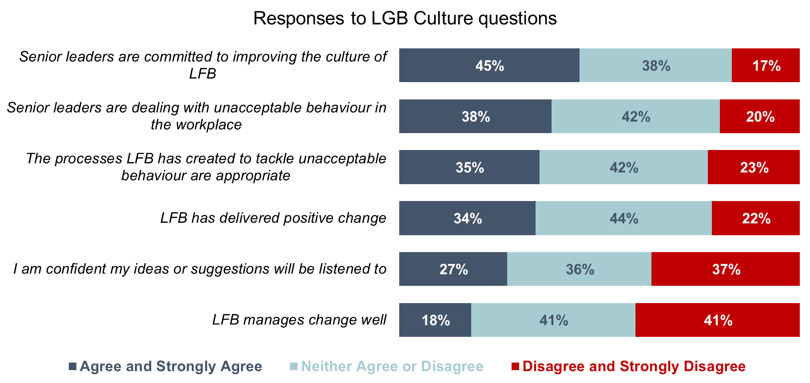

The Committee was not able to consider LFB’s latest survey results, which we heard in our meeting found had high levels of engagement. Deputy Commissioner, Jonathan Smith, told the Committee:

“We are just analysing our most recent staff survey which has just finished. 74 per cent of the workforce have completed that staff survey and if you look at comparisons in other Fire and Rescue Services (FRS) across the country, no one else has anywhere near that level of engagement that we are seeing. That is going to tell us a story about the organisation that we will be able to put in front of this Committee for rigorous scrutiny to make sure that what we think is happening at the most strategic level of the organisation is the lived reality because, again, reflecting on what Martin was saying before, it is what the lived reality of our staff is like, whether it is on fire stations, whether it is in Control, whether it is in our FRS departments is how we really know that the strategic intent of the organisation is having the outcomes that we would expect to see.”

LFB shared this survey data with the Committee on a confidential basis. Given the need for transparency and openness in building trust and confidence, we think it should be shared publicly, and we were disappointed not to be able to reflect it in this report. Without access to this information, we are left with only a partial picture of LFB’s progress on these metrics.

The Committee agrees with HMICFRS’ findings that the levels of confidence in LFB’s feedback processes need to increase. We recognise this will take time, and that the PSU has only been in place for a little over a year. Nonetheless, we would expect clear signals to emerge in the coming months and years in LFB’s survey data. By sharing this information publicly, LFB can demonstrate clearly the progress everyone involved wants to see being made. Actions speak louder than words; the LFC has spoken to the Committee regularly about the need for transparency and openness. We agree. The Committee, Londoners, but most importantly, firefighters themselves, deserve to see what is happening in this space.

Recommendation 5
To demonstrate increased trust and confidence, London Fire Brigade should raise its Key Performance Indicator for levels of staff who would recommend London Fire Brigade as a place to work to 65 per cent by January 2026 and 70 per cent by January 2027.
Recommendation 6
As part of London Fire Brigade’s commitment to transparency and openness it should continue to survey its workforce at least annually, and publish the findings of the surveys.

Mental health support
It can be incredibly traumatic for any individual going through a complaints and grievance process. In this investigation, we have heard about developments in the FRS sector to support the health and wellbeing of firefighters and brigade staff as well as the particular issues with how firefighters in London are being supported by LFB.

Anna Snelson a firefighter with LFB and member of Women in the Fire Service, told the Committee:

“[I]f you make a complaint or if you are someone who has had a complaint made against you, there is no support mechanism there at all. Like Gareth [Cook, FBU] said, it is then up to the unions or us to then support that person. I can say hand on my heart that I have not had any formal training in that. I do not know, it might be different for the FBU but we were like, ‘What?’ There is literally nobody just to, say, phone them up a week later and ask, ‘Are you alright?’ Someone has gone along and made a very serious complaint and then no one has gone, ‘Are you OK to get home?’ or that sort of thing, just compassionately thinking about that actual person rather than writing down the details and then investigating. It is just having a bit of humanity, I suppose, as well.”

We also heard directly from firefighters in our informal meetings about individuals with suicidal thoughts not receiving any contact for up to two months. Further, that the support that is available often has long waiting lists.

This is troubling in and of itself. But, given the wider challenges around health and wellbeing in the fire sector it needs to be looked at urgently. Research published in 2023 in the Journal Scientific Reports concluded that the rate of depression amongst UK firefighters is three times that of the general population. Known risk factors that affect this include “exposure to trauma, high-stress situations, and disrupted sleep.”

Dr Rowena Hill MBE, Professor of Resilience, Emergencies and Disaster Science at Nottingham Trent University was a guest at our meeting and has looked at these issues in depth. She shared with the Committee the findings of a research project she led for the National Firefighters Charity and NFCC, which has resulted in the creation of the NFCC Health and Wellbeing Framework. She told the Committee that this research had shown that “The profile of needs is changing in our fire and rescue services”. As a result, the health and wellbeing framework has been developed around a ‘whole-person’ and system-wide approach to health and wellbeing. Dr Hill told the Committee:

“It [the health and wellbeing framework] was around a holistic package, looking at somebody not just as a work resource that has work challenges but that they have a work/life domain and the two are bi-directional in their impacts. Also looking at that holistic aspect of physical, psychological and social health. That is that sense of belonging, that sense of ‘I am part of the fire and rescue service’, my pride in my role, that they care about me and want me to be a flourishing human being, that more holistic sense of that. Also, holistic across the career and holistic across those different job roles.”

As Gareth Cook summarised it: “You need to make sure that you are psychologically well, physically well and that you are able to bring your best self to work, to ensure that your colleagues’ physical and emotional safety is there also.”

The LFC and his Deputy Commissioner Jonathan Smith referenced various new processes and welfare provisions that are being made available to LFB staff. Jonathan Smith told us:

“Those welfare facilities exist. We have much better sign posted mechanisms now than we probably did when this started 18 months ago and we are continuing to learn from it, but those Welfare Officers have direct access into me and my team. If there are things that are not happening as far as that welfare provision is concerned, we are able to interject and make sure that people are getting the support they need.”

Gareth Cook praised LFB for the improvements being made but said “there is still quite a lot of distance to travel.” Similarly, Anna Snelson told the Committee that while the welfare provisions may be improving, there is a question about whether they are being accessed. She told us:

“There are facilities available for people, but whether they can access them at that time. The issue a lot of people have, I find from being the co-chair of the Women in the Fire Service [UK] London region, is trying to get the information out to people on stations or people who do not work at headquarters. There is still a lot of work to be done there because how do you reach those people? Not everybody is logging on to a computer every day. That is not part of their role. They might not log on at all for that whole tour if they are a firefighter. If it does not fall for them, they might not do that. How do we reach out to those people so that they know that that support is there, and it is all right for them to do it?”

Fig 2: Stress, Anxiety and Depression as a percentage of total sickness absence (2019-2024)
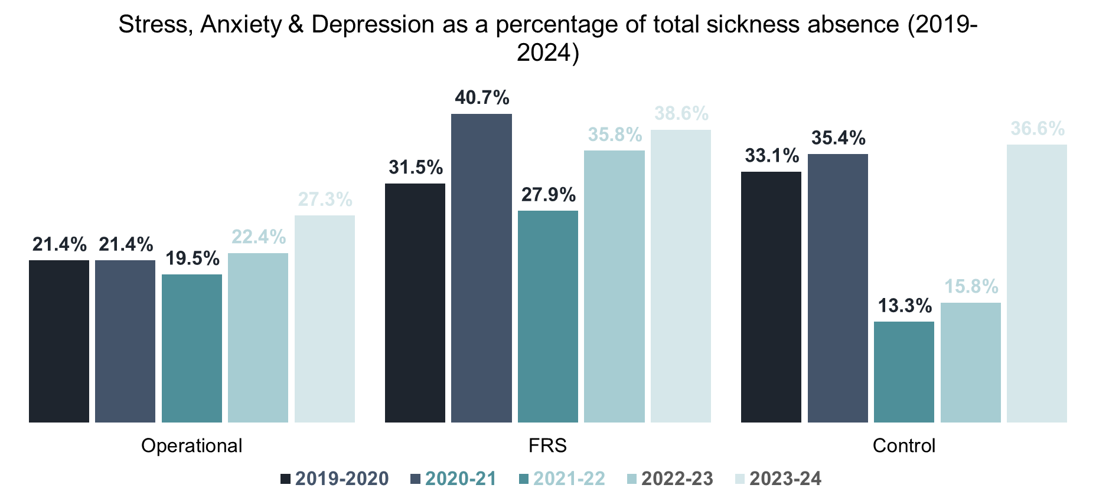
The LFC acknowledged, “There is probably never enough we can do because it [complaints and grievance process] is just an inherently stressful process, but I would not seek to diminish the experience of colleagues who either are suspended or are themselves complainants who also want resolution.” The LFC concluded “It is the one place I feel continuously restless about because we have had too many examples of where colleagues have suffered real damage that you would feel complacent about it.”

The Committee recognises that grievance processes are inherently stressful experiences. There are also welcome signs of progress in terms of the welfare provision being made available. Yet, we have heard through this investigation that mental health and counselling support during the PSU’s formal procedures is not felt to be readily available, with reports of a waiting list for those requesting counselling. Like the LFC, we are acutely aware of the need for LFB to be constantly challenging itself in this space to do the best it can to support its people. This will require a redoubled and concerted effort to ensure that all LFB staff are made fully aware of the newly available welfare provisions, and how to access them. But also, for LFB to ensure that these services are equipped to deal with the demands placed upon it.
Recommendation 7
London Fire Brigade should introduce a new key performance indicator on waiting list times for those seeking mental health support services, and take active steps to reduce these waiting times.

Equality, diversity and inclusion
The Culture Review highlighted some of the Commissioner’s comments from a March 2021 interview where he conceded that a culture of casual racism and misogyny existed in pockets at LFB. The Review quoted the Commissioner saying:

“The benchmark for me is I’ve got a young mixed-heritage daughter,” he added. “Can I say with confidence that she will be treated with dignity and respect in every single part of the London Fire Brigade? No I can’t.”

We wanted to know whether that has changed in the intervening years. Whether LFB is on the way to becoming a welcoming, modern, and representative employer and organisation. And what more needs to be done to get there.

Making LFB more representative
Currently, LFB is not representative of London. Deborah Riviere-Williams told the Committee that “we [LFB] do not reflect London” as there are “still issues around promotions, employment, who is sitting where within the LFB.”

LFB’s latest People Services Performance data, covering the period Q3-Q4 of 2023-24, indicated that 18.7 per cent of its workforce were women, 18.1 per cent were from an ethnic minority and just over six per cent were lesbian, gay or bisexual.

Compared nationally, LFB is outperforming fire and rescue services across England on all these metrics. But as the LFC remarked; London is extraordinary, it does not look like the rest of the country. We therefore strongly endorse his ambition set out to the Committee to make LFB’s demographics match London’s. We agree with the LFC that “you have to set yourself a target to represent the London population if we are truly a public sector organisation representing our city”.

These bold statements need bolder actions – particularly around recruitment. This will not be simple. As Dr Jessica White told the Committee: “if you want to encourage a positive culture in your service you need to bring in more diversity” but highlighted that “nobody who is from a diverse background wants to come into a service where they feel that they are not going to have a good experience.”

HMICFRS found in its inspection of LFB that there is good support for those with a protected characteristics through a range of staff networks, and that most staff that it spoke to felt equality, diversity and inclusion (EDI) had improved in the brigade. However, LFB acknowledged that “it could use positive action more effectively to recruit a more diverse workforce.” It told HMICFRS in 2024 that targeted social media campaigns “hadn’t resulted in an increase in diverse candidates becoming firefighters and that it needs to evaluate and monitor positive action.”

The Committee welcomes LFB’s recognition of the scale of this issue. The Committee sees building a Brigade that reflects London as a crucial step in building a Brigade that truly represents it and can encourage a positive culture. As Deborah Riviere-Williams told us: “If you do not have diversity within the different grades and ranks, how do you effect the changes that you want to see?”

Once recruited, there is also a challenge around retention of more diverse staff. Paula Lyons of Women in the Fire Service told the Committee about the pressures on someone being the first – or one of the first – to do something. She told us:

“I have certainly found myself in that position and it feels like all eyes are on you. You feel like you cannot do anything wrong. It is around having that support for people as well and sometimes recognising, if the service itself is not in that place, then that is where we need to reach out to other services. We can reach out to Women in the Fire Service. Make sure that not just allyship but support, mentoring and coaching or peer support is there as well.”

We have heard that LFB needs a new approach to attracting and retaining more diverse candidates into the service. And that once there, they need more support, mentorship, and allies in senior positions. There is no short-term fix, but immediate actions are required. The LFC acknowledged that “what I am not going to sit here and say is that we still do not have problems around structural lack of opportunity for both women and Black colleagues because to do so would be to completely diminish their experience and disrespect them.”
Recommendation 8
London Fire Brigade should publish a new strategy for attracting and retaining more diverse candidates into the service, by the end of March 2026. It should address existing barriers in terms of outreach, recruitment channels and incentive structures for applicants.

Disproportionality within formal procedures
Martin Forde KC told the Committee:

“if you feel that your complaints are not taken seriously, or if you feel that a complaint made against you has resulted in more serious action than if it had been made against somebody else, or if you feel the threshold for referring you, or taking out a grievance against you, or making a complaint against you is lower because you have a protected characteristic, than somebody who does not, then that is a serious problem.”

This issue of disproportionality was highlighted in Nazir Afzal’s 2022 Independent Culture Review. It outlined that minority ethnic staff were more likely to raise a grievance and twice as likely to be subject to disciplinary hearings in comparison to their white counterparts.

The data available currently to the Committee around disproportionality covers a much broader period from 2019 to 2024. This includes complaints and misconduct predating the PSU. What this data shows is that the numbers of grievances raised by those with protected characteristics has been disproportionate to their composition within LFB’s workforce, as Figure 3 shows.

Fig 3: Proportion of grievances raised and proportion of total workforce, January 2019 - October 2024
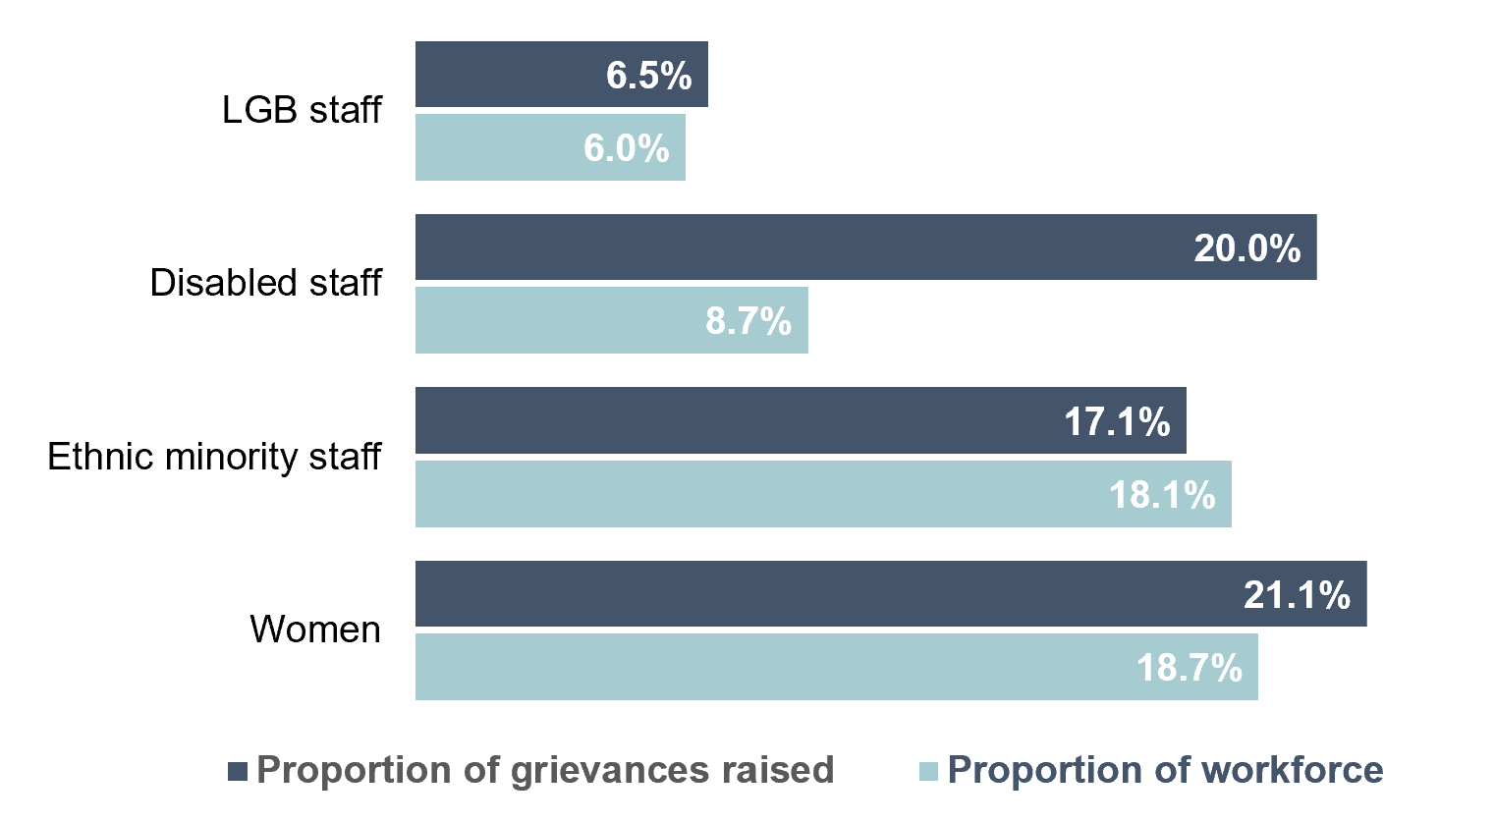

Further, in terms of disciplinary action taken as a result of investigations, Figure 4 shows that a disproportionate number have been handed down to LGB staff, women and ethnic minority staff between January 2019 and October 2024, compared to their composition amongst the operational workforce:

Fig 4: Proportion of disciplinaries raised and proportion of total workforce, January 2019 - October 2024

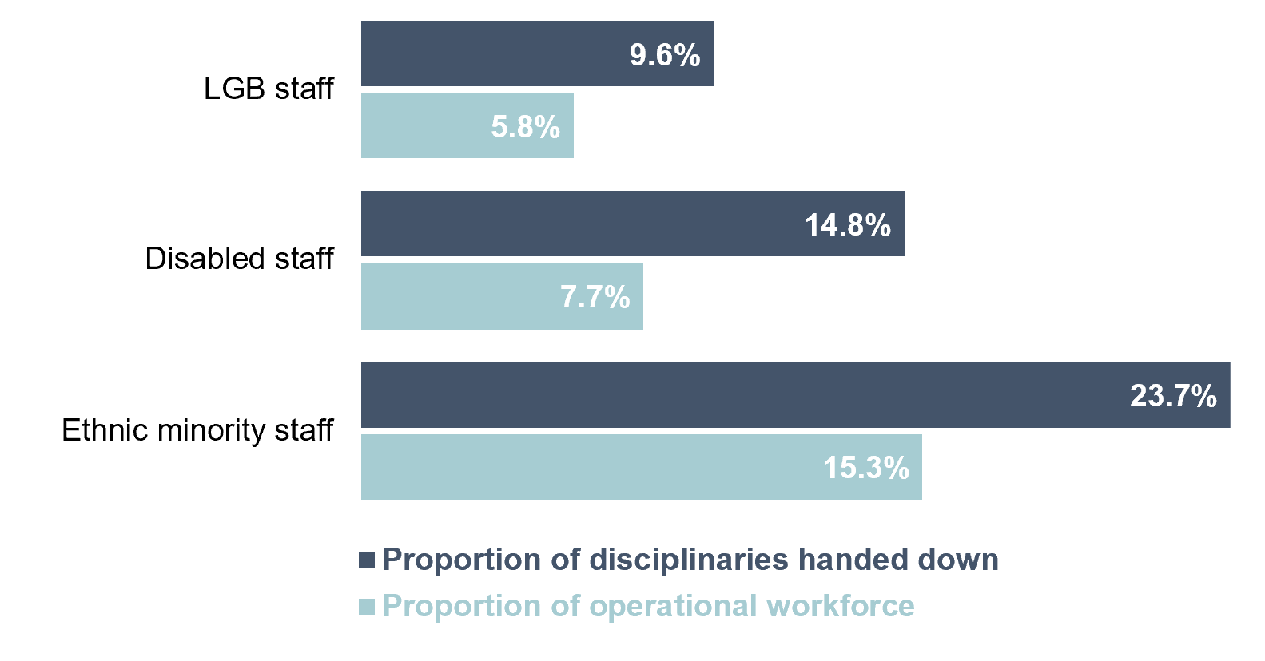

The Committee heard from LFB about its work to address these issues within the complaints and misconduct procedures. The LFC stated that “We have done a lot to eradicate disproportionality in discipline because […] we are now measuring it very, very carefully within the context of the PSU.” However, Deputy Commissioner Jonathan Smith stated that “because the PSU is still relatively new in its inception and the data set is quite small […] some of this we do not yet know. We do not yet know if this is a particular spike.”

The Independent Culture Review recommended that LFB “investigate the root causes” as to why this was. The Committee is concerned that LFB does not yet appear to have a clear understanding of the scale and specifics of disproportionality within the complaints and grievances procedures. Increased levels of disciplinary action being taken (where appropriate) could be a positive step in changing LFB’s culture. But, the evidence is not yet available to confirm that.

The Committee wants to see LFB commit to making a concerted push on analysis of disproportionality to inform the actions required to address this.
Recommendation 9
London Fire Brigade should carry out a review examining disproportionality in PSU cases covering its first 18 months of working January 2024-June 2025. This should include a thematic analysis of why cases are being raised by London Fire Brigade staff with protected characteristics, as well as the levels of disciplinaries handed down to these groups. London Fire Brigade should consult with the independent advisory panel as part of this review.

Watch culture
Watches are teams attached to a fire station. The environment that exists within a watch is referred to as “watch culture”. HMICFRS describes watch culture as: “The subculture that sometimes develops in watches when, as a result of operational staff working, training and living very closely together, they form a group with its own values and culture contrary to that of the fire service.” As Anne-Marie Barlow said, “Unless you have worked on another station or somewhere else in the country, you tend to work in the same environment with the same people for a really long time.”

Following the damning criticisms of watch culture in the Culture review, the Committee was keen to explore this topic with guests. What we heard was that watches are not inherently problematic and offer firefighters a vital support system within LFB. Dr Rowena Hill MBE outlined that whilst “we know that when that [watch culture] is negative, it is negative” but that “it is also one of the biggest protective factors”. She went on to identify that the “close co-worker network that provides social support is one of the biggest reasons and the biggest self-reported mechanism that people within the fire and rescue service use to maintain their health and wellbeing.”

Similarly, Paula Lyons reflected on her own career and the important support that came from her watch during traumatic circumstances. She told us:

“What I would say is there is no doubt, yes, there are some issues with toxicity on watches. We have seen that has played out in media and recent reports. However, I also say there is a place for that watch culture and, as someone who was part of a fatal fire where two of my colleagues sadly lost their lives, that environment with a watch that was supportive and was there to help each other through that time and for many years later was paramount and it had its place. We need to be conscious of looking at both sides.”

None of the guests disputed that there may be instances of toxic work cultures in certain watches across LFB. Yet, they all emphasised that in those cases it may only be one or two individuals who are responsible. What is concerning to the Committee is whether LFB’s firefighters feel empowered to call out those individuals. The LFC was mindful of this challenge. He told the Committee:

“We do Watch leader days on a quarterly basis now. What is clear is they understand the values and they understand the behaviours they have to hold people to, but they speak very openly to the challenges of doing so in a tight-knit team where, literally, the person behind you is going to keep you alive.”

LFB’s senior leadership explained to the Committee the monitoring it undertakes to identify negative behaviours and misconduct. The LFC detailed that LFB “Heatmap[s] the whole of the organisation now, if we are talking about culture.” He went on to say that this approach reflects “a relentless determination to keep going, a systemic approach to using evidence to drive decision-making.” He confirmed LFB has “seen dismissals as a result.”

This data-led work will be crucial in identifying problems when it comes to complaints and grievances. There is also the challenge of driving culture change before it gets to complaints. For example, Martin Forde KC identified that firefighters may feel the need to conform to a certain set of behaviours in order to fit in. Reflecting on a conversation he had with a “a mixed heritage young man”, he told us, “I came away from that conversation wondering whether he felt, as he was in a minority on his Watch, that he had to express some slightly anti-progressive views in order to survive in that environment”.

Where these toxic cultures do exist, those firefighters won’t be as effective as they could otherwise be. Deborah Riviere-Williams highlighted that:

“[I]f you have a toxic watch, even if it does mean breaking people up, if you are working in that condition, under those circumstances, you are probably not as working as effectively as you could be if you were in a happy watch. For me, I would not be concerned about splitting people up, I would be more concerned about people not functioning as effectively because they are not happy, and they are just tolerating negative behaviours.”

LFB needs to root out where toxic watch cultures develop. We agree with Jonathan Smith that the bystander mentality is part of this. He told us:

“We are starting to see this play out in the disciplinary cases that, sadly, cross our desks. It is the bystander mentality. Just because you may not be involved in whatever the situation is, does not mean you do not have a duty to report that and actually to intervene if required. That bystander mentality is really important.”

Recommendation 10
London Fire Brigade should rollout bespoke bystander training aimed at the kinds of issues being identified within watches.

Committee Activity

The Fire Committee held two formal meetings as part of its investigation into fixing the culture at London Fire Brigade. The first meeting was held on 23 October 2024 and was attended by: Ann-Marie Barlow, Director, Energise Development; Suzanne McCarthy, Independent Chair, Fire Standards Board; Dr Jessica White, Acting Director of Terrorism and Conflict Studies, Royal United Services Institute; Dr Rowena Hill MBE, Professor of Resilience, Emergencies and Disaster Science, Nottingham Trent University; Paula Lyons, Company Secretary, Women in the Fire Service; Anna Snelson, LFB Women in the Fire Service; Gareth Cook, London Regional Organiser, Fire Brigades Union; Adam Shaw, London Regional Treasurer, Fire Brigades Union and Deborah Riviere Williams, Chair, Unison at LFB.

The Committee held a private informal meeting with a selection of firefighters or former firefighters, speaking on condition of confidentiality, about issues related to the investigation.

The Committee held a second informal meeting on 28 November 2024 focused on the Professional Standards Unit; this was attended by: Gareth Liptrot, (then) Head of Professional Services Unit, London Fire Brigade and Jonathan Smith, Deputy Commissioner, London Fire Brigade.

The Committee held its second formal meeting on 3 December 2024 which was attended by: Martin Forde KC, Independent Chair, London Fire Brigade’s Advisory Panel; LFC, London Fire Commissioner, London Fire Brigade and Jonathan Smith, Deputy Commissioner, Operational Preparedness and Response, London Fire Brigade.

Appendix
Organisations represented on LFB’s Advisory Board
- Home Office
- His Majesty’s Inspectorate of Constabulary and Fire & Rescue Services
- National Fire Chiefs Council
- Local Government Association
- Greater London Authority
- London Borough Councils
- Trades unions (three representatives)

Other formats and languages

If you, or someone you know needs this report in large print or braille, or a copy of the summary and main findings in another language, then please call us on: 020 7983 4100 or email assembly.translations@london.gov.uk
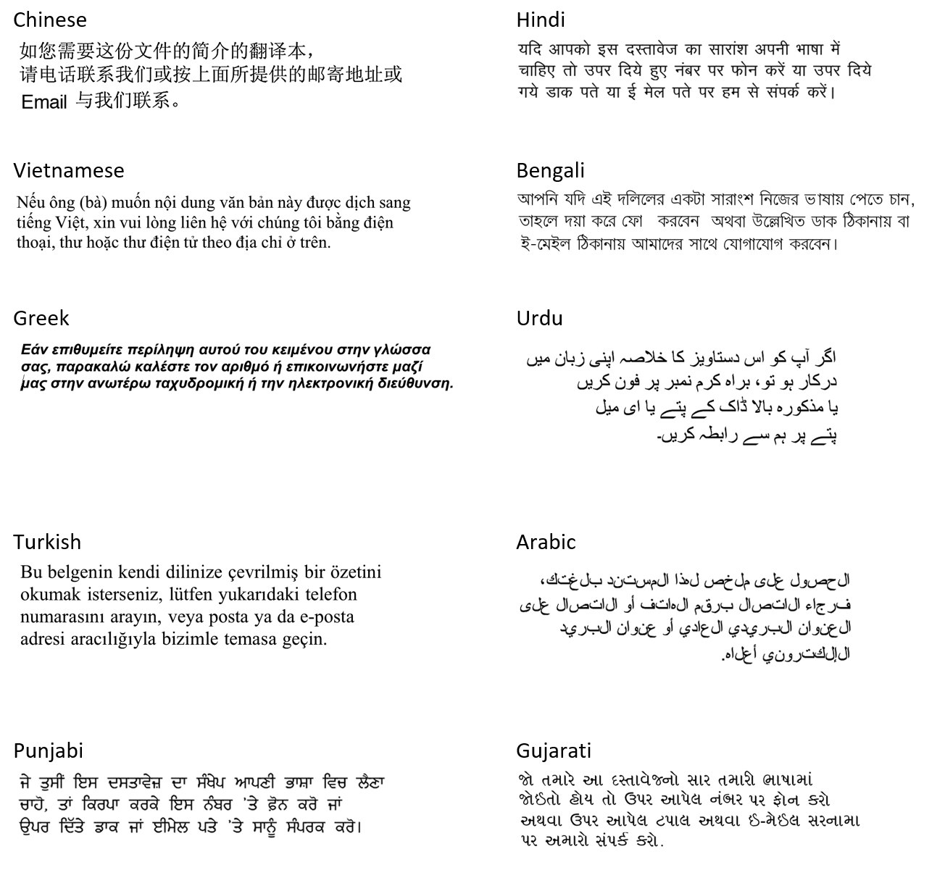

Connect with us

The London Assembly
City Hall
Kamal Chunchie Way
London E16 1ZE

Website: https://www.london.gov.uk/who-we-are/what-london-assembly-does
Phone: 020 7983 4000



Follow us on social media



Baroness Casey Review, Final Report, March 2023
NHS England, Culture review of ambulance trusts, 15 February 2024
London Fire Brigade, Brigade launches wide-reaching, external review of its culture, 18 March 2021
London Fire Brigade, Letter from Nazir Afzal OBE to LFC, 5 December 2023, p.1
HMICFRS, Fire and rescue services in Engage, [last updated 7 March 2025]
HMICFRS, Effectiveness, efficiency and people 2023–2025: London Fire Brigade, 29 November 2024
London Assembly, Assembly responds to HMICFRS inspection of London Fire Brigade, 29 November 2024
London Assembly Fire, Resilience and Emergency Planning Committee, Meeting report: Independent Culture Review of London Fire Brigade – One Year On, 5 December 2023
London Assembly Fire, Resilience and Emergency Planning Committee, Meeting report: Women in the London Fire Brigade, 14 November 2023
HMICFRS, Effectiveness, efficiency and people 2023–2025: London Fire Brigade, 29 November 2024, p.45
London Fire Brigade, Your London Fire Brigade 2023–2029, 1 January 2023, p.20
London Assembly Fire Committee, Meeting transcript: Panel 1, 24 October 2024, p.2
London Assembly Fire Committee, Meeting transcript: Panel 2, 3 December 2024, p.2
London Assembly Fire Committee, Meeting transcript: Panel 1, 24 October 2024, p.2
London Assembly Fire Committee, Meeting transcript: Panel 1, 2024, p.8
London Assembly Fire Committee, Meeting transcript: Panel 1, 24 October 2024, p.2
London Assembly Fire Committee, Meeting transcript: Panel 2, 24 October 2024, p.8
London Assembly Fire Committee, Meeting transcript: Panel 2, 3 December 2024, p.2
London Assembly Fire Committee, Meeting transcript: Panel 1, 24 October 2024, p.3
London Assembly Fire Committee, Meeting transcript: Panel 2, 24 October 2024, p.1
London Assembly Fire Committee, Meeting transcript: Panel 2, 3 December 2024, p.1
HMICFRS, Effectiveness, efficiency and people 2023–2025: London Fire Brigade, 29 November 2024
London Assembly Fire Committee, Meeting transcript: Panel 2, 3 December 2024, p.1
London Assembly Fire Committee, Meeting transcript: Panel 1, 24 October 2024, p.3
London Assembly Fire Committee, Meeting transcript: Panel 1, 24 October 2024, p.9
London Assembly Fire Committee, Meeting transcript: Panel 2, 3 December 2024, p.5
HMICFRS, Standards of behaviour: The handling of misconduct in fire and rescue services, 1 August 2024
London Fire Brigade, HMICFRS Values and Culture report: Progress Update, [accessed 13 February 2025]
London Assembly Fire, Resilience and Emergency Planning Committee, Meeting transcript, 5 December 2023, p.2
London Fire Brigade, Fire Committee Briefing: Response to Fixing the Culture at LFB, 27 November 2024
London Fire Brigade, Fire Committee Briefing: Response to Fixing the Culture at LFB, 27 November 2024
London Fire Brigade, Fire Committee Briefing: Response to Fixing the Culture at LFB, 27 November 2024
London Assembly Fire Committee, Meeting transcript: Panel 2, 3 December 2024, p.10
London Fire Brigade, London Fire Commissioner takes immediate action in response to culture review, 25 November 2022
London Fire Brigade, Review of Historical Cases, 27 January 2025
London Fire Brigade, Fire Committee Briefing: Response to Fixing the Culture at LFB, 27 November 2024
HMICFRS, Effectiveness, efficiency and people 2023–2025: London Fire Brigade, 29 November 2024
London Assembly Fire Committee, Meeting transcript: Panel 2, 24 October 2024, p.6
London Assembly Fire Committee, Meeting transcript: Panel 1, 3 December 2024, p.6
London Assembly Fire Committee, Meeting transcript: Panel 2, 3 December 2024, p.12
London Assembly Fire Committee, Meeting transcript: Panel 2, 24 October 2024, p.12
London Assembly Fire Committee, Meeting transcript: Panel 2, 3 December 2024, p.12
London Assembly Fire Committee, Meeting transcript: Panel 2, 3 December 2024, p.11
Baroness Casey Review, Report on Misconduct, October 2022
Baroness Casey Review, Report on Misconduct, October 2022, p.13
London Assembly, MQ 2024/3130 [Culture in the London Fire Brigade (LFB) (11)], 15 October 2024
London Assembly, MQ 2024/3128 [Culture in the London Fire Brigade (LFB) (9)], 15 October 2024
LFB’s submission to the Committee explains that “A third stage hearing is held when an offence is sufficiently serious and follows an investigation by the PSU (or its external provider CMP under the Independent Culture Review recommendations); such a hearing can produce the sanction of dismissal.”
London Fire Brigade, Fire Committee Briefing: Response to Fixing the Culture at LFB, 27 November 2024
London Assembly Fire Committee, Meeting transcript: Panel 2, 3 December 2024, p.5
London Assembly Fire Committee, Meeting transcript: Panel 2, 24 October 2024, p.6
London Assembly Fire Committee, Meeting transcript: Panel 2, 24 October 2024, p.12
London Assembly Fire Committee, Meeting transcript: Panel 1, 3 December 2024, p.10
London Assembly Fire Committee, Meeting transcript: Panel 2, 24 October 2024, p.6
London Fire Commissioner, Letter to Chair of Fire Committee, 21 March 2025
London Assembly Fire Committee, Meeting transcript: Panel 2, 3 December 2024, p.16
London Fire Brigade, Fire Committee Briefing: Response to Fixing the Culture at LFB, 27 November 2024
London Fire Brigade, Fire Committee Briefing: Response to Fixing the Culture at LFB, 27 November 2024
London Fire Brigade, Fire Committee Briefing: Response to Fixing the Culture at LFB, 27 November 2024
London Fire Brigade, Fire Committee Briefing: Response to Fixing the Culture at LFB, 27 November 2024
London Fire Brigade, Fire Committee Briefing: Response to Fixing the Culture at LFB, 27 November 2024
London Assembly Fire Committee, Meeting transcript: Panel 2, 3 December 2024, p.16
London Assembly Fire Committee, Meeting transcript: Panel 2, 3 December 2024, p.17
London Fire Brigade, Fire Committee Briefing: Response to Fixing the Culture at LFB, 27 November 2024
London Assembly Fire Committee, Meeting transcript: Panel 1, 24 October 2024, p.7
London Assembly Fire Committee, Meeting transcript: Panel 2, 24 October 2024, p.13
London Assembly Fire Committee, Meeting transcript: Panel 2, 24 October 2024, p.8
London Assembly Fire Committee, Meeting transcript: Panel 1, 24 October 2024, p.7
London Assembly Fire Committee, Meeting transcript: Panel 1, 3 December 2024, p.10
London Assembly Fire Committee, Meeting transcript: Panel 2, 3 December 2024, p.17
Fire Standards Board, Approved Standards, [accessed 21 February 2025]
London Assembly Fire Committee, Meeting transcript: Panel 1, 24 October 2024, p.3
London Assembly Fire Committee, Meeting transcript: Panel 1, 24 October 2024, p.9
London Assembly Fire Committee, Meeting transcript: Panel 1, 24 October 2024, p.8
UK Parliament, UIN 30723 [Fire and Rescue Services: Standards], 19 February 2025
London Assembly Fire Committee, Meeting transcript: Panel 2, 3 December 2024, p.28
Police Federation, Quick Reference Guide, 6 December 2023
London Assembly Fire Committee, Meeting transcript: Panel 2, 24 October 2024, p.10
London Assembly Fire Committee, Meeting transcript: Panel 2, 24 October 2024, p.11
London Assembly Fire Committee, Meeting transcript: Panel 2, 24 October 2024, p.11
HMICFRS, Values and culture in fire and rescue services, 30 March 2023
National Fire Chiefs Council, NFCC response to London Assembly Fire, Resilience and Emergency Planning Committee, 14 February 2024
HMICFRS, Values and culture in fire and rescue services, 30 March 2023
Grenfell Tower Inquiry, Grenfell Tower Inquiry: Phase 2 Report, 4 September 2024
Ministry of Housing Communities & Local Government, Grenfell Tower Inquiry Phase 2 Report: Government response, 26 February 2025
London Assembly Fire, Resilience and Emergency Planning Committee, Letter to Chair National Fire Chiefs Council, 17 January 2024
Nazir Afzal OBE, Independent Culture Review of London Fire Brigade, November 2022
Nazir Afzal OBE, Independent Culture Review of London Fire Brigade, November 2022
HMICFRS, Effectiveness, efficiency and people 2023–2025: London Fire Brigade, 29 November 2024
HMICFRS, Effectiveness, efficiency and people 2023–2025: London Fire Brigade, 29 November 2024
London Assembly Fire Committee, Meeting transcript: Panel 1, 24 October 2024, p.5
London Fire Brigade, Fire Committee Briefing: Response to Fixing the Culture at LFB, 27 November 2024
London Assembly Fire Committee, Agenda papers, 2023 Your LFB Your Voice: All Staff Survey Results [Annex A], 11 July 2024
London Assembly Fire Committee, Agenda papers, 2023 Your LFB Your Voice: All Staff Survey Results [Annex A], 11 July 2024
London Assembly Fire Committee, Meeting transcript: Panel 2, 3 December 2024, p.3-4
London Assembly Fire Committee, Meeting transcript: Panel 2, 24 October 2024, p.6
Wolffe et al, Mental health of UK firefighters, 10 January 2023
Wolffe et al, Mental health of UK firefighters, 10 January 2023
National Fire Chiefs Council, Health and Wellbeing framework, [accessed 21 February 2025]
London Assembly Fire Committee, Meeting transcript: Panel 1, 24 October 2024, p.10
London Assembly Fire Committee, Meeting transcript: Panel 1, 24 October 2024, p.11
London Assembly Fire Committee, Meeting transcript: Panel 2, 24 October 2024, p.1
London Assembly Fire Committee, Meeting transcript: Panel 2, 3 December 2024, p.21-22
London Assembly Fire Committee, Meeting transcript: Panel 2, 24 October 2024, p.2
London Assembly Fire Committee, Meeting transcript: Panel 2, 24 October 2024, p.4
London Datastore, LFB people data and performance, [accessed 31 October 2024]
London Assembly Fire Committee, Meeting transcript: Panel 2, 3 December 2024, p.20-21
Nazir Afzal OBE, Independent Culture Review of London Fire Brigade, November 2022
London Assembly Fire Committee, Meeting transcript: Panel 2, 24 October 2024, p.19
London Datastore, LFB people data and performance, [accessed 1 April 2025]
Home Office, Fire and rescue workforce and pensions statistics: England, year ending March 2024, 17 October 2024
London Assembly Fire Committee, Meeting transcript: Panel 2, 3 December 2024, p.6
London Assembly Fire Committee, Meeting transcript: Panel 1, 24 October 2024, p.4
HMICFRS, Effectiveness, efficiency and people 2023–2025: London Fire Brigade, 29 November 2024
HMICFRS, Effectiveness, efficiency and people 2023–2025: London Fire Brigade, 29 November 2024
London Assembly Fire Committee, Meeting transcript: Panel 2, 24 October 2024, p.19
London Assembly Fire Committee, Meeting transcript: Panel 2, 24 October 2024, p.20
London Assembly Fire Committee, Meeting transcript: Panel 2, 3 December 2024, p.10
London Assembly Fire Committee, Meeting transcript: Panel 1, 3 December 2024, p.5
The terminology used to refer to this group in the report was “BAME”.
London Assembly, MQ 2024/3130 [Culture in the London Fire Brigade (LFB) (11)], 15 October 2024
The total number of grievances raised by individuals between January 2019 and October 2024 was 275.
London Assembly, MQ 2024/3126 [Culture in the London Fire Brigade (LFB) (7)], 15 October 2024
The total number of disciplinaries handed down between January 2019 and October 2024 was 135. The data for women has not been included in this visualisation as the London Fire Brigade has not provided a single number. Instead, they have shared that there were five or less cases involving female members of staff. This would put the proportion of disciplinaries handed down to female firefighters between zero per cent and 3.7 per cent.
London Assembly Fire Committee, Meeting transcript: Panel 2, 3 December 2024, p.10
London Assembly Fire Committee, Meeting transcript: Panel 2, 3 December 2024, p.14
Nazir Afzal OBE, Independent Culture Review of London Fire Brigade, November 2022
HMICFRS, Watch culture, [accessed 22 February 2025]
London Assembly Fire Committee, Meeting transcript: Panel 1, 24 October 2024, p.6
London Assembly Fire Committee, Meeting transcript: Panel 1, 24 October 2024, p.1
London Assembly Fire Committee, Meeting transcript: Panel 2, 24 October 2024, p.14
London Assembly Fire Committee, Meeting transcript: Panel 2, 3 December 2024, p.17
London Assembly Fire Committee, Meeting transcript: Panel 2, 3 December 2024, p.3
London Assembly Fire Committee, Meeting transcript: Panel 2, 3 December 2024, p.23
London Assembly Fire Committee, Meeting transcript: Panel 1, 3 December 2024, p.3
London Assembly Fire Committee, Meeting transcript: Panel 2, 24 October 2024, p.18
London Assembly Fire Committee, Meeting transcript: Panel 2, 3 December 2024, p.26
London Fire Brigade, Establishment of an Advisory Panel following Culture Review and appointment of an Independent Chair, 23 August 2023

