Andrew Boff AM

Chair of the Planning and Regeneration Committee

City Hall

Kamal Chunchie Way

London

E16 1ZE

25 June 2025

Dear Andrew

**COMMITTEE REPORT ON SOCIAL VALUE**

At Places for London, we share your commitment to serving London’s diverse, dynamic communities who drive our city forward. We are also committed to regeneration that people truly value, and we also firmly believe that such regeneration should enhance, rather than erode, the social fabric of our city.

As I outlined when we met in December 2024, we are in the process of upgrading much of our estate to better support existing and future customers and local communities, including making it safer, more resilient to climate change, and more accessible.

We are proud to be investing over £300 million in our arches and retail portfolio. Of this, around £100 million is dedicated to helping us achieve our goal of becoming net zero carbon by 2030.

When we spoke to the committee, we also discussed how we are preparing both a document outlining our approach to creating Social Value and our Arches Strategy. Together, there will outline our approach to delivering social value across the estate.

Rather than pre-empt the content of these strategies, we propose providing a full response upon their publication later this year.

In the meantime, we are pleased to confirm that publishing our approach to Social Value will fulfil the recommendation to publish what was previously referred to as our Inclusive Growth Strategy.

We anticipate sharing the Arches Strategy with the Land & Property Committee of the TfL Board in the autumn, with a draft being published as part of the meeting papers. Our Retail Strategy will be discussed with the Land & Property Committee in July. We are confident that both our approach to Social Value and the Arches Strategy will be published by the end of the year, and we will be happy to share them with the Committee and provide an update once available.

We look forward to sharing our full response in due course and to continuing our joint efforts to help shape a more inclusive, resilient, and vibrant London.

I would of course be happy to provide any additional information if required.

Yours faithfully,

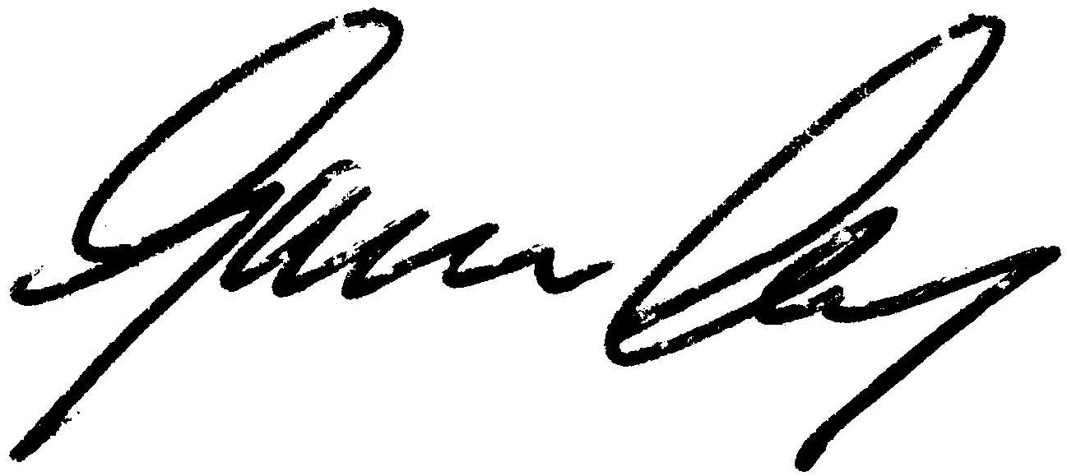

**Graeme Craig**

Director & Chief Executive

Email: [graemecraig@tfl.gov.uk](mailto:graemecraig@tfl.gov.uk)